Photooxidative Degradation of EDTA in aqueous solutions by Pulsed UV radiation with continuous spectrum
Kamrukov A.S., Kozlov N.P., Novikov D.O., Yalovik M.S.
Research institute of Power Engineering Faculty BMSTU, Moscow, Russia
The decontamination of nuclear power plant equipment produce large quantities of solutions contaminated with radioactive elements. Localization, concentration and processing of liquid radioactive waste (LRW) is greatly simplified after the removal or destruction they contain chelating (sodium ethylenediaminetetraacetate - EDTA) that bind radionuclides and complicate their selection of traditional physical and chemical methods. One of the most effective ways is to oxidative and photooxidative degradation.
The paper presents results of experiments on photooxidation complexing organic compounds using high-intensity pulsed radiation UV continuum. On irradiation of solutions large negative influence high salt concentration NaNO₃, which is part of LRW, which absorbs a significant proportion of UV radiation in the work area of the spectrum.
Aqueous solutions of EDTA containing NaNO₃, were irradiated with a pulsed xenon lamp INP-7/120 in the presence of hydrogen peroxide at a concentration of 3 g/l.
Chromatogram of the degradation products of aqueous solution containing: - EDTA with an initial concentration of 15 mg/l - with H₂O₂ concentration of 3 g/l, - NaNO₃ at a concentration of
4 g/l before and after irradiation is shown in Fig.
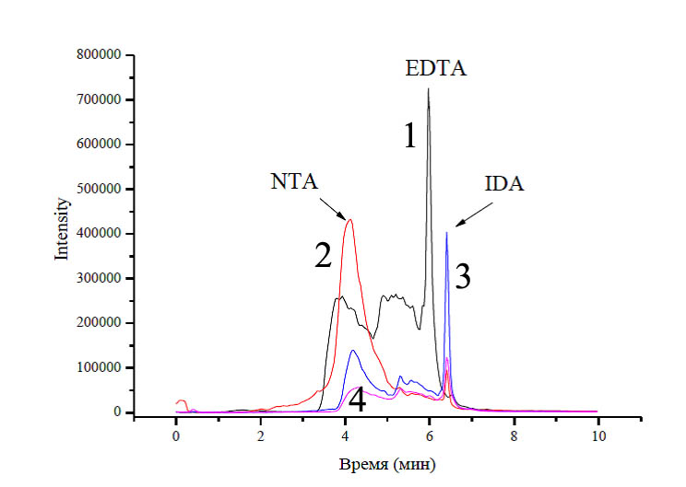
1 - aqueous solution without irradiation;
2 - aqueous solution after UV irradiation dose volume 0.3 J/cm³;
3 - aqueous solution after UV irradiation dose volume 0.6 J/cm³;
4 - aqueous solution after UV irradiation dose volume 3 J/cm³.

It can be seen that irradiation of the solution with a volume dose of UV radiation is 0.3 J/cm³ almost complete destruction of EDTA. At this energy irradiation appear EDTA degradation products, namely, nitrilotriacetic acid (NTA) - curve 2 and a small amount of iminodiacetic acid (IDA). Further exposure to UV radiation increases the number of IDA and reduces NTA (curve 3). In this case, the mass spectrum appears intense peak CO₂ molecule - one of the products of partial mineralization of EDTA. With further irradiation degradation products are present in smaller amounts, but the dose of UV radiation in the above experiment was insufficient for complete mineralization of EDTA (curve 4).
The results of this study show promise of a combination of optical and plasma oxidation methods for sewage containing LRW.

