electron temperature MeasurEMENTS in microplasma discharges on the surface of titanium BY USING optical spectrum
V.A. Ivanov, M.E. Konyzhev, A.M. Zimin*, V.I. Troinov*, A.A. Letunov, T.I. Kamolova
A.M. Prokhorov General Physics Institute of RAS, Moscow, Russia, ivanov@fpl.gpi.ru
*N.E. Bauman Moscow State Technical University, Moscow, Russia
As a result of interaction in vacuum pulsed plasma flow with a density of 10¹³ cm⁻³ and duration of 10 μs with titanium samples, covered by a thin dielectric film of 1 μm thickness, microplasma discharges are excited on the surface of the samples [1]. The optical spectra of light emission from plasma were registered and investigated in the case when microplasma discharges were characterized by the amplitude of electric current of 200 A and pulse duration of 20 ms. The analysis of the optical spectra have showed that in the wavelength range 350−800 nm in these spectra there are mainly emission lines of atoms and singly charged ions of titanium. The doubly- and triply-ionized titanium atom lines were not found.
The model of local thermodynamic equilibrium in discharge plasma and statistical methods [2] were used for calculation of an electron temperature in microplasma discharges on the basis of the values of relative intensities of more than a hundred spectral emission lines of atoms and ions of titanium. This temperature is 0.18 eV (calculated for the lines of excited atoms of titanium), and 1.2 eV (calculated for the lines of excited singly charged ions of titanium).
The value of electron temperature, determined from the ratio of the relative intensities of spectral emission lines of titanium atoms, corresponds to the region of the plasma which is located nearest to the surface of the molten titanium at the temperature closed to the melting temperature of 2000 K, i. e, 0.18 eV. When the plasma moves from the surface of titanium, then the value of electron temperature rises up to 1.2 eV and concentration of titanium ions and their excitation increases.
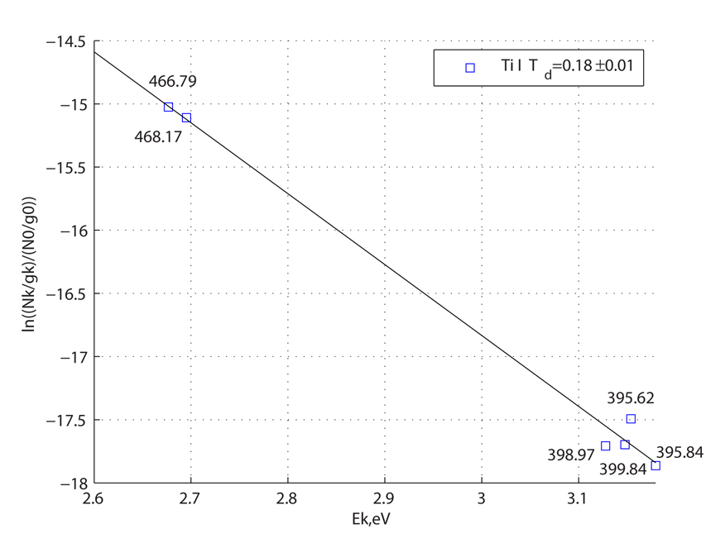 | This is the dependence of relative populations of excited levels of titanium atoms in semi-logarithmic scale, on the excitation energy Ek of the titanium atom lines (Ti I) in the wavelength range 400 − 480 nm. Average electron temperature in plasma is Td ≈ 0.18± 0.01 eV. The numbers next to the experimental points correspond to the wavelengths (nm) of emission lines of the titanium atoms excited in the microplasma discharge.
This work was supported by the Russian Foundation for Basic Research, project # 13-08-01174.
Refrences
- V.A. Ivanov, A.S. Sakharov, M.E. Konyzhev. Plasma Physics Reports, 2008, V.34. No.2. P.150.
- V.M. Gradov, A.M. Zimin, S.E. Krivitskiy, A.V. Shumov. // VANT. Seriya “Termoyaderniy Sintez”. 2009. No. 1. Pp 64-71.

