Simulation Of the IONIZATION of the plasma vibrator antenna
Bogachev N., *Bogdankevich I., *Gusein-zade N., *Tarakanov V.
MSTU MIREA, Moscow, Russia, bgniknik@yandex.ru
*A.M. Prokhorov General Physics Institute of the Russian Academy of Sciences Moscow,
Russia, bira@fpl.gpi.ru
In recent years has been actively working on the development and research of antennas with electrically controllable parameters and in particular the plasma antennas [1-3]. Special attention is paid to the plasma asymmetric quarter-vibrator [2,3]. Despite a number of theoretical studies (see, eg, [4]), peculiarity the work of the plasma antenna lead to the need for numerical simulations [2,6].
In this work, as in [2,6] to model the plasma antenna was selected full electrodynamic code «KARAT», but the main attention is paid to the gas ionization field RF waves and plasma excitation. The scheme of the numerical experiment is shown in fig 1. Left on the coaxial cable to the dielectric tube with ε=5, filled with gas, supplied TEM wave at a given frequency f and intensity E~300 V / cm, is ionized gas with the number of carriers up to a certain concentration, and then the antenna goes into EM radiation the wave. Plasma is presented PiC-model. In the calculation of the frequency f, plasma density n_{e}, the geometric dimensions of the antenna were changed.
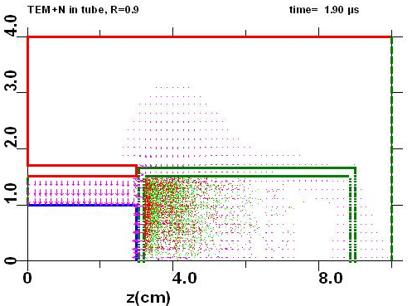
The study was supported by The Ministry of education and science of Russia, project 8392.

Рис.1. The schematic of the numerical model.
References
- G. G. Borg, J. H. Harris, N. M. Martin, D. Thorncraft, R. Milliken, et. al / Physics of Plasmas, -2000, V- 7, P- 2198.
- E. N. Istomin, D. M. Karfidov, I. M. Minaev, A. A. Rukhadze, V. P. Tarakanov, K. F. Sergeichev, and A. Yu. Trefilov // Plasma Physics Reports, Vol. 32, No. 5, 2006, p. 388
- I. M. Minaev, N. G. Gusein-zade, and K. Z. Rukhadze // Plasma Physics Reports, Vol. 36, No. 10, 2010, p. 914
- I. M. Minaev, N. G. Gusein-zade, A. A. Rukhadze and K. Z. Rukhadze // Radiotekhnika i elektronika, 2011, V 56, p.1216-1220
- N. Bogachev, I. Bogdankevich, N. Gusein-zade, V. Tarakanov Computer simulation of the receiving plasma vibrator antenna. Abstracts of XXXIX ^{th} Zvenigorod International Conference on Plasma Physics and Controlled Fusion, Zvenigorod, Russia, 2012

