Thermoelectric potential of weakly non-uniform collisionless cylindrical maxwellian plasmas
V.A. Rantsev-Kartinov
TPI NRC «Kurchatov institute», Moscow, Russia, rank@nfi.kiae.ru
By reasoning from expression of potential of a test particle which is moving in a plasma [1] and by considering the plasma as a sum of such test particles, in paper the calculations of potential $\left\langle ϕ(\vec{r})\right\rangle$, of maxvellian, weakly non-uniform, cylindrical plasma are resulted at small (in comparison with thermal) values of macroscopic velocities. As a result of these calculations it is obtained:
1) The formula of potential of plasma in the above conditions which specifies its thermoelectric character, and it can be presented as: $\left\langle ϕ(\vec{r})\right\rangle =− α(U)⋅T_{e}\left(r\right)$, where $U\left(r\right)=Z_{\text{eff}}\left(r\right)⋅\frac{T_{e}\left(r\right)}{T_{i}\left(r\right)}$, а $α(U)$ - thermo-electric coefficient (TEC);
2) TEC identically addresses into zero in two cases: a) at $V_{e}≡V_{i}$; b) in real experimental conditions when the inequality is fair $V_{e}\text{>>}V_{i}$, the requirement of the conversion into zero of the calculated potential is equivalently to the requirement $ω≡\vec{k}{\vec{v}}_{e}$, that corresponds to longitudinal electrostatic fluctuations and static, i.e., to screening of Debye;
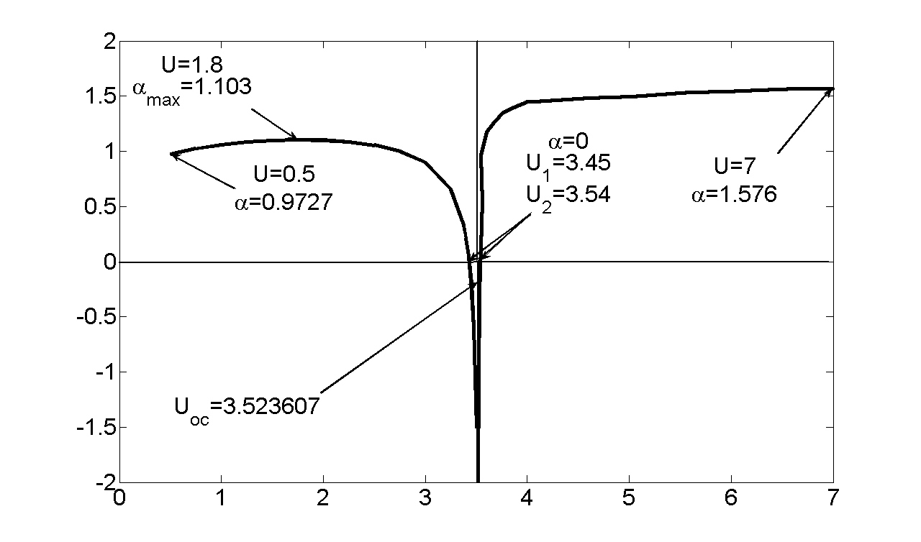
3) obtained TEC has some feature, where under (see figure), which is obtained purely mathematically but the author did not find its physical interpretation;
4) on the boundaries of the interval $3\text{.}\text{45}≤U\left(r\right)≤3\text{.}\text{54}$, TEC is equal to zero, while inside it the TEC is negative and potential is positive;
5) in the range of manifestation of the peculiarity the fluctuations of plasma are allowable, whose phase velocity and frequency satisfy the conditions: ${\left(\frac{ω}{k}\right)}_{\text{min}}≥3\text{.}5⋅V_{i}$, $ω≥ω_{\text{min}}≈0\text{.}3⋅Ω_{i}$, i.e., they can be attributed to a category of intermediate frequencies ;
6) the analytical expressions of TEC obtained for various ranges of change of parameter $U\left(r\right)$ and the table for area of feature allow to construct radial distributions of thermoelectric potential, and intensity of thermoelectric field.
The obtained value of electric field is only one of components of its total value which should be calculated having in view components of Hall fields of plasma currents which are taking place into it and various methods of its additional heating.
Literature
- V.P. Silin, " Introduction in the kinetic theory of gases Moscow, "Science", (1971)

