Superluminal velocities in quantum optics
B.A. Veklenko, Yu.I. Malachov*, N.K. Shi*
JIHT RAS, Moscow,Russia, VeklenkoBA@yandex.ru
*MPEI, Moscow,Russia, yumalakhov@yandex.ru, nguyenquocshi@yahoo.com
Every atom being in excited state creates in its vicinity the electromagnetic background with character dimension where is the mean live time of its excited state. The external photon acting on such atom breaks down its background and creates the scattering signal with a forerunner which passes ahead of the ballistic front at a distance. The forerunner gives the opportunity to transmit the signals with the velocities bigger than the light velocity in vacuum [1]. On the fig.1 the principle experimental installation is shown for investigation of the forerunner. This installation was described before in [2]. Number 3 denotes the hitting tube, 4 and 5 –photo receivers. Our experimental data according to the theory posed in [1] and coinciding to the relation
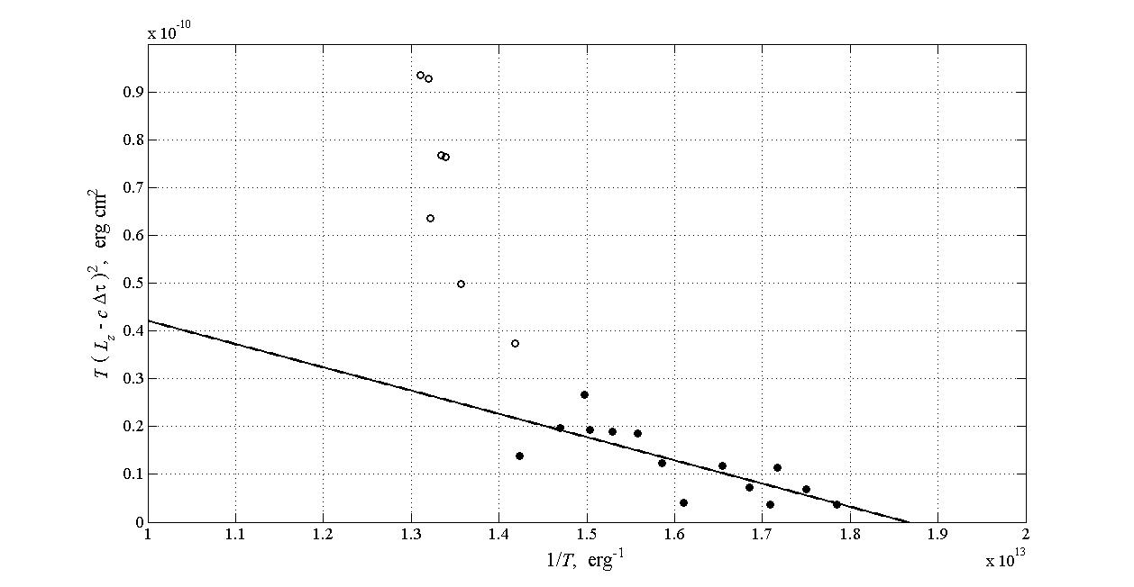
are plotted on a fig.2. Here is the wave number of the scattering light, is difference between register actions of photoreceptors. Instead of the natural width in calculations the Doppler width was taken into account since the experiment was placed in an air at temperature .The slope of approximating line posses the opportunity to find the resonant frequency of scattering media atoms. By posing, which corresponds to masses of air molecules we find or . The table numbers of oscillations of air molecule frequencies are consequently and . Since the nitrogen molecules constitute of air and in our calculations the gas of two level atoms as approximate medium was used than the coinciding between experimental and table numbers is considered as acceptable.

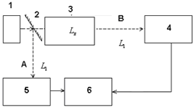

Fig.1. Experimental installation Fig.2. Experimental data.
References
- Veklenko B.A. Applied Physics . 2010, №3. 10 , (in Russian).
- Yu.I.Malachov, M.Ja.Ivanov, N.K.Shi, V.V.Shaulov. ХI Zababachin’s lectures. RFJaTs-VNIITF, Book of abstracts, Snejinsk, 2012, 132.

