INVESTIGATION OF THE INFLUENCE OF RF-PLASMA TREATMENT OF CAPACITIVE DISCHARGE ON THE CHARACTERISTICS OF CUTTING TOOLS OF MATERIAL OF COLD WORK TOOL STEELS (D SERIES)
I. Abdullin, I. Vasiliev
Kazan National Research Technological University, Russia, Kazan city, ilham.v@ya.ru
Most cutting tools are used for the machining of organic fibrous materials. In fur companies such tools are used for planing and split skins. One of the problems in a fur enterprises is a fast wear of cutting tools from such material. Hardening of cutting tools is relevant.
PVD method does not allow to condense wear-resistant coatings on tools which is made ​​of material of cold work tool steels because in process of cleaning the temperature reaches up to 700 ˚ C. This leads to the reduces the hardness. Therefore, before the PVD coating is carry out the process to RF plasma treatment.
Experiments were carried out on an experimental of RF capacitive plasma installation in the University.
Studies have shown that plasma capacitive discharge significantly affects only the roughness parameter, microhardness and structure of the samples did not change, this implies that in a capacitive discharge during the processing of occurs the minimum adsorption of the plasma gas (argon) to the surface of the sample as well as a moderate temperature influence. After plasma exposure surface of steel becomes more homogeneous, reduced height of asperities, are removed from the surface of impurity defects, so and the roughness parameter is reduced by 26-33% (Figure 1).
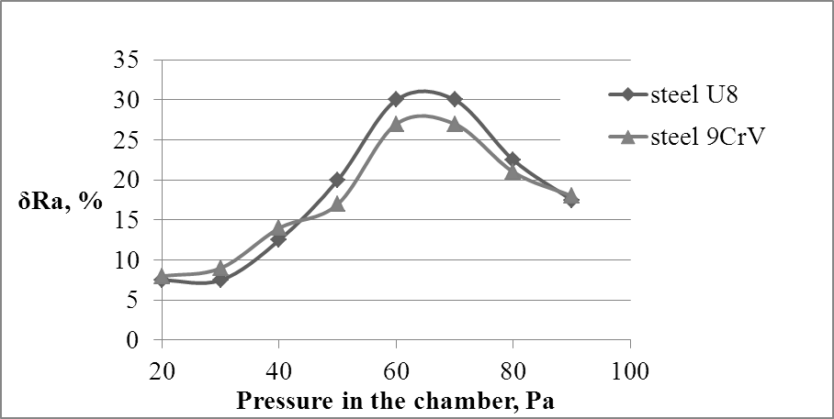
Figure 1 - Dependence of relative change of the parameter of roughness off the pressure of the plasma gas-argon in the chamber, (δR_{a}= (R_{a0} – R_{a})·100/ R_{a0}).
The quality of cleaning is estimated to cover the uniformity of color, which condensed after cleaning and corrosion resistance, adhesion of the coating.

