On the electron energy distribution In the positive column of gas discharge - PARADOX Langmuir
S.A. Maiorov
A.M. Prokhorov General Physics Institute, Moscow, Russia, mayorov_sa@mail.ru
In this paper we consider the electron drift in the electric field, which is a periodic disturbance of power character. [1] At drift electron acquires energy by Joule heating and loses in elastic collisions with atoms, spends excitation and ionization of atomic levels.

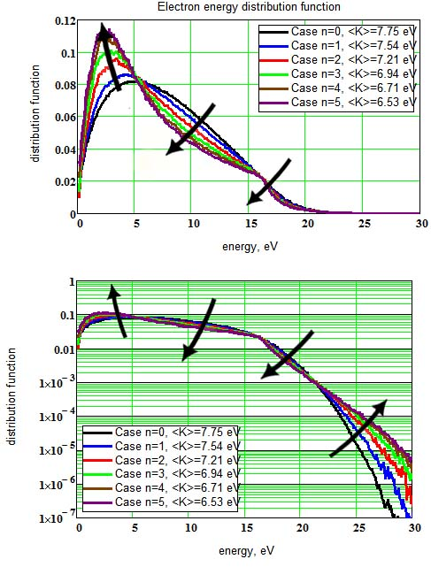
In Fig. shows the functions of the electron energy distribution in the drift in the periodic electric field (E / N = 10 Td, neon-field period of 4 cm, the field 4 V / cm). The different curves correspond to different values ​​of the exponent field inhomogeneity. The arrows indicate the direction of change of functions with increasing field fluctuations.
Comparison of calculated using the Monte Carlo distribution functions of the electron energy with the Maxwell distribution shows that the large heterogeneity of the periodic field there is a very good agreement. Ie from the simulation results that the spatial inhomogeneity of the field can lead to Maxwellization electrons in the glow discharge Townsend. This phenomenon Maxwellization electrons at low gas pressures is the subject of a long-known and much-discussed paradox Langmuir [2].
The study was supported by The Ministry of education and science of Russia, project 8392.
References
- Maiorov S.A., Brief reports on physics LPI, 2013, in print.
- Cendin L., UFN, 2010, 133, issue. 4, 948.

