Simulation of the recombination
in non-ideal ultracold plasmas
Yu.V. Dumin
Space Research Institute RAS, Moscow, RF
Institute of Terrestrial Magnetism, Ionosphere, and Radio Wave Propagation RAS,
Moscow, RF, dumin@yahoo.com
The problem of calculation of the recombination rate appears in various branches of plasma physics, particularly, in the description of ultracold plasmas investigated in the magneto-optical traps, as well as in the installations for synthesis of antihydrogen. A theoretical treatment in the above-mentioned cases is considerably complicated by strong Coulomb’s coupling; so that not only three-body but also multi-body interactions can play a significant role. As a result, the numerical methods are usually necessary. Unfortunately, a simultaneous description of free and quasi-bound motion of the charged particles is a serious computational challenge, because the time–space scales of the respective motions are very different. For example, formation of the quasi-bound electron–ion pairs in the well-known papers [1] was identified by a very few (e.g., four) revolutions of the electron about the ion.
The aim of the present report is to show results of a much more accurate computation, fulfilled by the approach developed in our previous paper [2]. The respective algorithm was designed initially to calculate the adiabatic equation for ultracold plasmas, but unexpectedly it demonstrated also a high efficiency in the simulation of recombination processes.
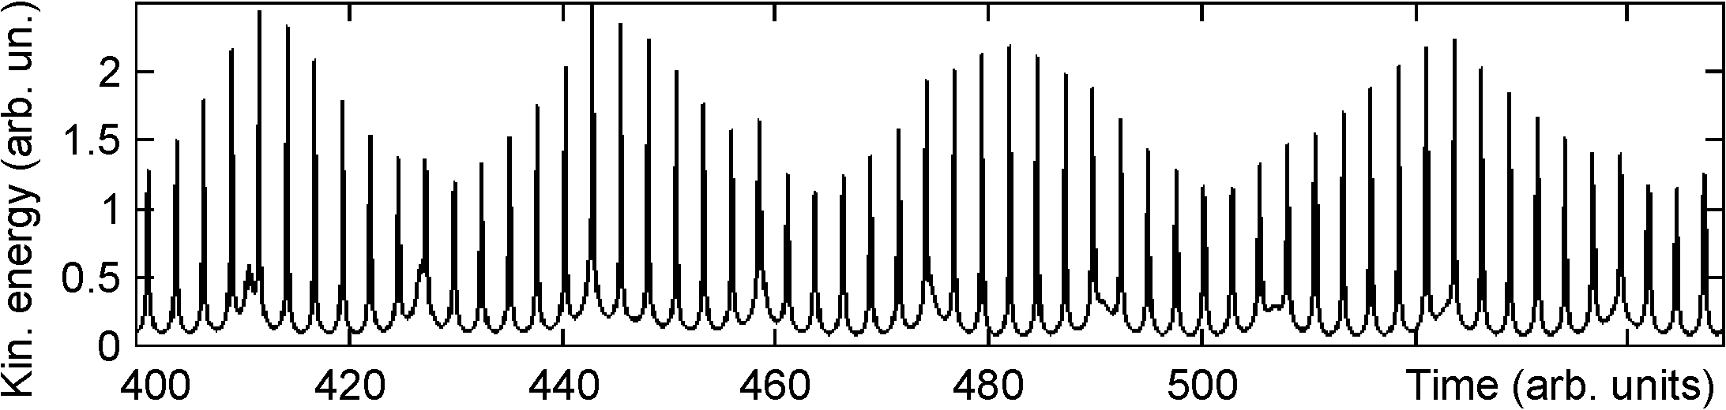
As an example, this picture illustrates behavior of the kinetic energy for the sample of 10 electrons in the expanding and cooling plasma cloud. It is seen at the sufficiently large times that there are almost regular oscillations with several (in this particular case, two) characteristic periods. They correspond to the motion of quasi-bound electrons about the ions by the elliptic orbits, when each passage of the electron near the pericenter results in a sharp jump in both kinetic and potential (Coulomb’s) energies of the entire sample. As follows from the figure, our numerical algorithm is able to simulate reliably the existence of such electron–ion pairs in the course of many dozens of revolutions. Therefore, we expect that it will become an efficient method for modeling the recombination processes in strongly-coupled plasmas.
The present work was performed in the framework of RFBR project No. 13-02-00458.
References
- Lankin A.V., Norman G.E. J. Phys. A: Math. Theor., 2009, vol. 42, p. 214032; p. 214042.
- Dumin Yu.V. Plasma Physics Reports, 2011, vol. 37, p. 858.

