On nuclear burning of p–B¹¹ at deep potential well of vacuum discharge. PIC modeling
Yu.K. Kurilenkov, V.P. Tarakanov, S.Yu. Gus’kov*
Joint Institute for High Temperatures, Russian Academy of Sciences, Izhorskaya Str., 13,
125412 Moscow, Russia,yukurilenkov@rambler.ru
*Lebedev Physics Institute, 119991 Moscow, Russia
The generation of energetic ions and DD neutrons from microfusion at the interelectrode space of a low energy (~ 1 J) nanosecond vacuum discharge (NVD) with deuterium-loaded Pd anode has been demonstrated earlier [1,2]. To understand better the physics of fusion processes the detailed PIC simulation of the discharge experimental conditions have been developed using a fully electrodynamic code KARAT [2]. The principal role of a virtual cathode (VC) and the corresponding single and double potential well (PW) formed in the interelectrode space were recognised. Deuterons D⁺ are accelerating by this well up to energies of few tens keV that provides DD nuclear synthesis under head-on ions collisions (the review of experimental data and modelling results related are presented at [2]). At the present work PIC modeling of processes of forming of virtual cathodes and potential wells at nanosecond vacuum discharge (NVD) have been continued. Close cylindrical electrostatic trap have been considered under higher voltage and discharge current ( up to 250 kV , 7 kA) than earlier[2]. The key values and characteristics were obtained which illustrate the physics of fusion at cylindrical electrostatic trap. Our results obtained indicate on opportunity of р- B¹¹ fusion at vacuum discharge also, if sufficiently deep potential well (fig.1a) would be realized at NVD experiment under higher voltage. Calculated example of energies of protons (W _{max} = 100-130 keV) and boron ions (Z= +3, W _{max} = 350-500 keV) oscillating at PW are given at fig.1b. The moments of coinciding collapses of protons and boron ions will be accompanied by curtain р- B¹¹ fusion. Remark the new program for р- B¹¹ fusion under extreme plasma parameters of dense plasma focus [3].
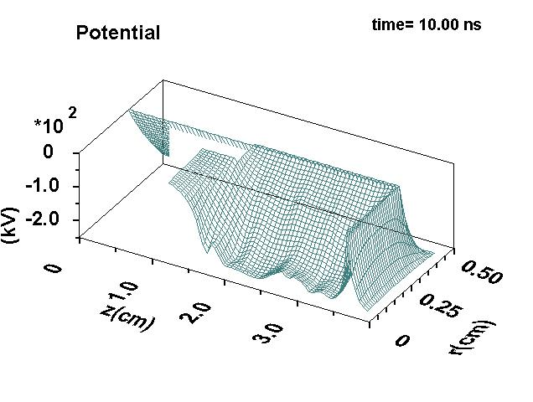 a) 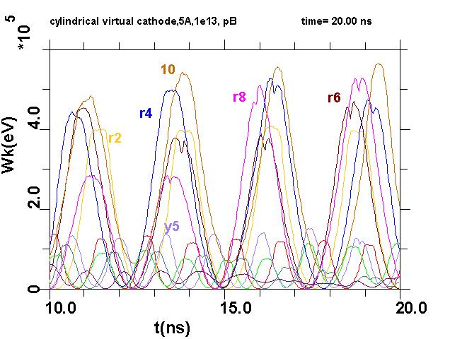 б)
Fig.1 (a) Potential well at 10th nanosecond of PIC modeling NVD (b) Energies of particular groups of oscillating protons (index – y) and boron ions ( index - r) as function of time (U= 250 kV, I = 7 kA)
References
- Yu.K. Kurilenkov, V.P. Tarakahov, S.Yu. Gus’kov et al. J.Phys. A: Math &Theor 42 (2009) 214041; Yu. K. Kurilenkov et al. Plasma Physics Reports 36 (2010)1227–1234.
- Yu. K. Kurilenkov , V.P.Tarakahov, S.Yu. Gus’kov et al. Contrib. Plasma Phys. 51 (2011) 427.
- E.J.Lerner, S.K Murali and A.Haboub. J.Fusion Energy 30 (2011) 367-376

