CURRENT PROGRESS ON PORT PLUG TEST FACILLITY FOR ITER IN RF
Romannikov A., *Levesy B., Krasilnikov A., **Skorodumov B., **Tarasova E., **Rumyantsev Y., **Allin M., ***Cerisier T., **Kotusov S., **Kuzmenco I. and JSC “Cryogenmash” team
ITER Agency, NRC «Kurchatov Institute»,Moscow, Russia, a.romannikov@iterrf.ru
*ITER Organization, Route de Vinon sur Verdon, 13115 Saint Paul Lez Durance, France
**JSC “Cryogenmash”, 143907 Moscow reg., Balashikha, Russia
***CNIM, Z.I de Brégaillon 83507 La Seyne sur mer
To achieve the overall ITER machine availability target, it is mandatory to test the port plugs at operating temperature before installation on the machine and after refurbishment.
The ITER port plug test facility (PPTF) provides the possibility to test upper and equatorial port plugs before installation on the machine.
“Project Center ITER” and “Cryogenmash” have carried out construction and calculations of all the subsystems of the test stand at the current stage. The major subsystems are:
-vacuum system;
-heating system;
- control system;
- PSS system and etc.
The report describes the characteristics of subsystems and the issues of integration of vacuum stands in a "hot cell" ITER.

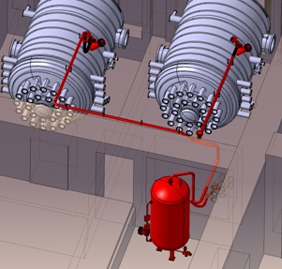
The example of PSS for PPTF in Hot Cell

