POSITIONS OF SOLAR FLARE CURRENT SHEETS OBTAINED ABOVE THE REAL ACTIVE REGION BY MHD SIMULATION
A.I. Podgorny, *I.M. Podgorny
Lebedev Physical Institute RAS, Moscow, Russia, podgorny@fian.fiandns.mipt.ru
*Institute for Astronomy RAS, Moscow, Russia, podgorny@inasan.ru
The 3D numerical simulation shows that magnetic energy in solar corona is stored at current sheet creation due to disturbances focusing in the vicinity of a magnetic singular line. The typical time for creation of a powerful current sheet is about 3 days. To predict a solar flare appearance it is necessary to reveal current sheet creation. The common method of current sheet position definition consists in finding a singular line position from potential magnetic field above the active region. For calculation of the potential magnetic field, distribution on the photosphere is approximated by local magnetic sources (charges or dipoles). Such approach is to crude and does not take in account the fact that usually series of several flares appear, and each flare is produced by its own current sheet. For finding positions of all current sheets above an active region the full system of MHD equation is solved taking into account change the photospheric magnetic field distribution obtained from preflare measurements. The example of numerical simulation is shown in the figure. To take into account all singularities of magnetic field configuration, 3D MHD simulations are performed in the numerical domain which size is several times bigger then the size of active region. The details of setting initial-boundary problem for MHD simulations in real active region and numerical methods developed for this purposes are described in [1, 2]. The results of calculation for a real solar flare and comparison with observation are presented. In the present simulation we perform calculation in shorter time scale for technical reason. To find current sheet positions more precisely in future it is necessary to avoid creation of currents, which are appear not in the sheets and are caused by unrealistic fast changing of magnetic field on the photosphere in performed calculations.
References
- Podgorny, A. I. and Podgorny, I. M.: 2008, Astronomy Report. 52, 666.
- Podgorny A. I., Podgorny I. M, Meshalkina N. S.: 2008: Journal of Atmospheric and Solar-Terr. Phys. 70, 621.

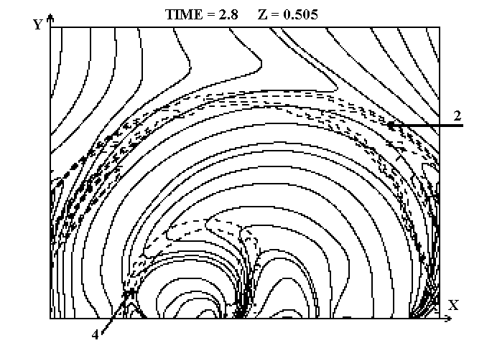

Figure. Magnetic field configuration and lines of equal current density (dashed lines).

