HELICOIDAL SYSTEM FOR AXIAL CONFINEMENT OR PLASMA ACCELERATION
Beklemishev A.D.
Budker Institute of Nuclear Physics and Novosibirsk State University, Novosibirsk, Russia, bekl@bk.ru
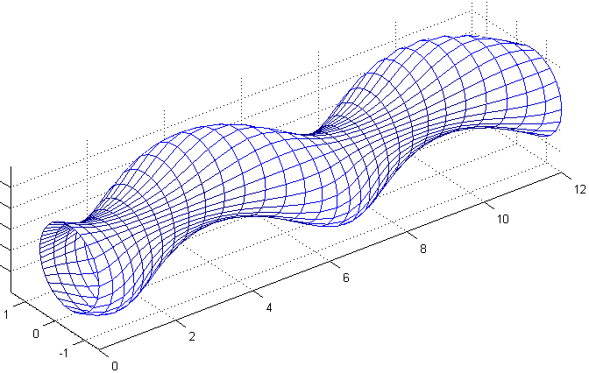
One way of reduction of axial losses in open magnetic traps is the multiple-mirror confinement. It is realized, for example, in the GOL-3 device in the Budker Institute of Nuclear Physics, and its efficiency is demonstrated. In a multiple-mirror system the axial plasma flow is restrained by collisional friction with particles trapped in cells of the corrugated magnetic field, and, as a result, the plasma flow becomes diffusive. It means, that axial losses are inversely proportional to the system length. If one could provide an additional plasma flow along its gradient into the trap, axial losses would be reduced exponentially instead of linearly. In this paper the principle scheme of the “pump” for producing such a flow is presented. Of course, it may have other applications besides modification of the multiple-mirror confinement.
The system is based on the helicoidal geometry of the magnetic field (see figure) and resembles early theoretical models of stellarator field. The structure of magnetic surfaces in such systems was described by Morozov and Soloviev [1]. Along all field lines except the magnetic axis the field is corrugated, so that the multiple-mirror confinement holds. However, if the plasma in such a system is rotated in a radial electric field, its helical symmetry will lead to generation of an axial flow. A direct analog of the process is observed in tokamaks: there is a well-known relationship between the toroidal and poloidal plasma rotation. In contrast to tokamaks, in an open system there can be a direct control over the distribution of the radial electric field via end-plate electrodes. Such a system should be operational both in the kinetic regime (due to drift of trapped particles) and in the hydrodynamic regime (due to high parallel viscosity). Single-thread systems (as shown) are preferable, since they can provide higher field corrugation near the magnetic axis.
Azimuthal asymmetry of the system combined with the declared purpose of frictional momentum transfer leads to inevitable radial drifts of the confined plasma. However, such drifts need not lead to radial losses. Indeed, unlike in toroidal systems, in open traps one has direct control over the direction of the drift. Positive ions drift toward the negative pole of the applied radial potential. Thus, in order to turn losses into the pinch effect, one has to apply negative potential on axis. This does not restrict the direction of pumping since there is one additional variable choice, namely, the choice between the left and right system helicity. Estimates show that the proposed systems are potentially capable of generating flow velocities comparable to the sound speed.
Bibliography
- Morozov A.I., Soloviev L.S., in Reviews of Plasma Physics. 2, Consultants Bureau (1966)

