Characteristic features of accelerated electrons on Lower Hybrid Carrent Drive experiments in the FT-2 tokamak
S.I. Lashkul, V.V. Rozhdestvensky, A.B. Altukhov, V.V. Dyachenko, L.A. Esipov,
M.Yu. Kantor, D.V. Kouprienko, S.V. Krikunov
A.F. Ioffe Physico-Technical Institute Politekhnicheskaya 26, 194021, St.Petersburg
Experiments on the LHCD efficiency in the tokamak FT-2, [1], were persisted. The data obtained by laser Thomson scattering, SXR and HXR measurements, bolometric and synchrotron emission diagnostics were used for these purpose. Recently LHCD experiment at <n_{e}>= 0.9 10¹⁹m⁻³ with longer LHW pulse duration Δt_{RF}=14ms (P_{RF} = 100kW, 920MHz) and the inductive plasma current I_{pl} = 35kA) reveals rise of T_{e}(y=0cm) from 400eV to 600eV before the RF pulse end. It was demonstrated, that residual vortex electrical field, increasing velocity and quantity of superthermal electrons generated by LH wave higher than critical value, results in substantial rise of runaway electron beam energy and density. During LHCD the abrupt powerful (ΔP_{RF} ~30÷50kW) radiation losses were registered by collimated bolometer. These one can be associated with synchrotron emission of accelerated electrons, but not impurity radiation. The synchrotron emission substantial rise registered in the frequency range (53 ÷ 156) GHz at <n_{e}> ~ 1.7*10¹⁹m⁻³ was carried out by spikes of the such emission at frequencies (53 ÷ 78) GHz as it is illustrated for in fig. 1 for 63.7 GHz. These spikes observed firstly in the ASDEX–U tokamak [2], are apparently produced due to cyclotron auto resonance between the runaways gyro motion and harmonics of the toroidal magnetic field ripples.
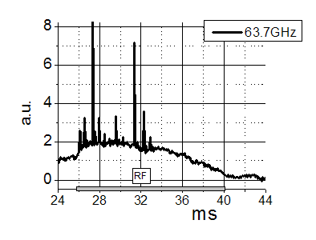
Fig. 1
The essential rise of HXR emission observed during LHCD is determined by nonthermal electrons produced by LHW and then accelerated in residual vortex electrical field and thus contributing to runaway beam. On the other hand, if the loop voltage at LHCD is small, HXR can be lower than the OH level. In the experiment during meander-like RF pulses U_{pl} signal falls down to the level at which HXR signal remains at the OH level or decreases below it. During interval between pulses, when U_{pl} rises, HXR signal increases dramatically because the comparatively long-living nonthermal electrons produced by LHW are accelerated by higher U_{pl}.
This work was supported by the RFBR grants N11-02-00561, 10-02-00631 and MSE grant No.
11.G34.31.0041
References
[1] S. I. Lashkul, A. B. Altukhov et. аl. /Pl. Physics Reports, 2010, Vol. 36, No. 9, pp. 751–761.
[2] B Kurzan K.-H. Steuer and W. Suttrop. Rev. Sci. Instrum. 68 (1). January 1997

