Stationary configurations of plasma in a tokamak in the approximation of two-fluid MHD
Gavrikov M.B., Savelyev V.V.
Keldysh Institute of Applied Mathematics RAS, Moscow, RF,
nadya_p@cognitive.ru, ssvvvv@rambler.ru
This report presents the first results on the equilibrium configurations of the tokamak plasma. Equilibrium is determined by the condition , but taking into full account the inertia of electrons, whose influence on the equilibrium leads to an additional equation for the function of the total current , absent in MHD plasmastatic. The result [1] is the system of two equations for the magnetic flux function and the function
(1)
The system (1) is closed by the Bernoulli (energy) and angular momentum integrals, which allow to determine the value of the azimuthal current and particle density
(2)
Here - and are arbitrary functions. The function determines the entropy of the electrons and is also considered as given. The figure gives an example of the level curves of and the electron pressure for a tokamak of a "triangular" cross section with the adiabatic index.
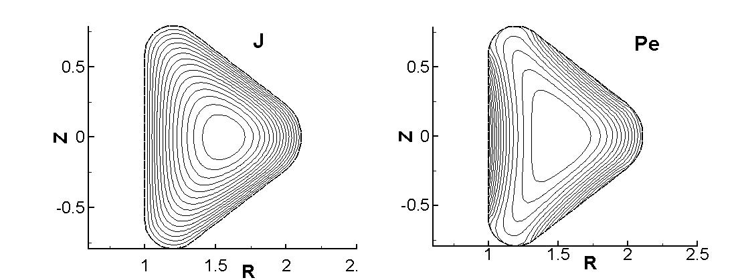

References
- Gavrikov M.B., Savelyev V.V., Journal of Mathematical Sciences, V.163, N.1, 2009, pp 1-40.

