Ion acceleration mechanism in the experiment on the generator REP "Katran" *)
DOI: 10.34854/ICPAF.2021.48.1.150
Belozerov O.S., Bakshaev Y.L., Khromov S.A., Dan’ko S.A.
NRC "Kurchatov Institute", Moscow, Russia, Belozerov_OS@nrcki.ru
There is the phenomenon of ion acceleration in pulsed generators of relativistic electron beams (REB) acting on a transparent load for them. The ion bunches energy can be several times higher than the applied voltage of the pulse generator multiplied by the ion charge. Experiments on the acceleration of ions were carried out on a «Kalmar» generator (voltage per pulse ~ 300 kV, current ~ 150 kA, pulse duration ~ 80 ns) [1]. To study the mechanism of acceleration of ion beams of megaelectron-volt energies, the diagnostic methods described in [1, 2] were used.
Fig. 1 shows a schema of the experiment, which was carried out with a gap between the cathode and anode in a high-voltage diode equal to ~ 7.5 mm. The anode was a 10 μm aluminum foil, behind which, at a distance b, there was a brass collimator 8-16 mm long with cylindrical holes. The collimator was intended to either eliminate the formation of a virtual cathode behind the foil or to limit the distance at which the virtual cathode could accelerate ions. Wherein, the collimator passes narrowly directed accelerated ions to the detectors.
In the first 15 starts, carried out without a gap b, ions could be accelerated only due to the vortex field arising in the high-voltage diode. The median values of E_{m} recorded by the ion energy sensors of six successive starts with a foil having a thickness of 10 μm and nine starts with a thinner foil are 201 and 471 keV, respectively. The average energies are 458 and 968 keV, respectively. Both presented characteristics for starts with a thinner foil are significantly higher,
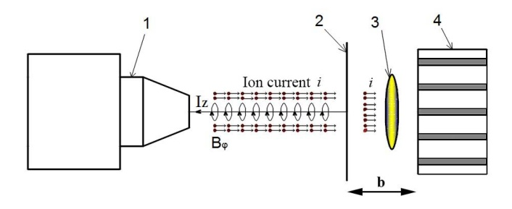
Fig. 1. Experiment scheme: 1 - cathode; 2 - anode foil; 3 - virtual cathode; 4 - collimator.
which indicates that acceleration occurs exclusively in the gap of the high-voltage diode, and ions are decelerated in the foil. The median values of the recalculated energy of ions that have not yet passed through the anode foil are 860 and 850 keV. These values are almost the same, which indicates that the parameters of the series starts were stable enough for the comparison. When the collimator was moved away from the anode foil, the acceleration of ions continues: the energy of ion bunches and their number increased monotonically to E_{p} = 1.5–3.5 MeV and N_{i}≈5×10¹⁰ at a distance of 30 mm. Apparently, when the collimator is moved away from the anode foil, the acceleration mechanism outside the high-voltage diode is activated, due to the field of the virtual cathode moving at a limited distance.
This work was carried out with the support of the National Research Center "Kurchatov Institute" (order of 09.10.2020 No. 2073).
References.
- O.S. Belozerov, S.A. Dan’ko and Ananyev S.S.// Problems of Atomic Science and Technology, series “Thermonuclear Fusion”. 2020 Vol. 43 No. 2 p. 80-86. DOI: 10.21517/0202-3822-2020-43-2-80-86.
- O.S. Belozerov, Yu.L. Bakshaev and S.A. Dan’ko// Problems of Atomic Science and Technology, series “Thermonuclear Fusion”. 2018 Vol. 41 No. 4 p. 99-105. DOI: 10.21517/0202-3822-2018-41-4-99-105.

*) abstracts of this report in Russian

