GENERATION OF IONS IN A MULTICOMPONENT PLASMA OF THE ACCELERATOR WITH CLOSED ELECTRON DRIFT *)
DOI: 10.34854/ICPAF.2021.48.1.146
¹Strokin N.A., ¹Kazantsev A.V., ²Bardakov V.M., ¹The Thang Nguyen, ¹Rigin A.V.
¹Irkutsk National Research Technical University strokin85@inbox.ru, kazanets@gmail.com,
nguen.tkhe@yandex.ru, arseniy.rigin@mail.ru
²Irkutsk State Transport University vmbardakov38@mail.ru
The successful continuation of work on creating a prototype of a plasma-optical mass separator largely depends on understanding the operation of a multicomponent ion flow source. In the layout of the plasma-optical mass separator, the POMS-E-3 [1] is a plasma accelerator with an anode layer (TAL). The creation of a new compact plasma analyzer “TANDEM”, which allows analyzing the ion flow by energy, mass, and charge [2], significantly expands the possibilities of studying both discharges in crossed TAL fields and the actual results of mass separation.
Figure 1 shows the dependences of the amplitude values of the current intensity of Ne⁺, Ar⁺, and Kr⁺ ions on the magnitude of the magnetic field induction at the TAL anode, measured by the TANDEM analyzer at the output of the POMS-E-3 azimuthator. Curve 4 in figure 1 is the dependence of the maximum values dI/dW taken from the total spectrum dI/dW = f (B_{A}) measured by an energy analyzer with a retarding potential (RFA). Comparison of these dependences makes it possible to determine the contribution of an ion of each mass to the total ion current and optimize the gas injection rates to achieve the specified partial ratios.
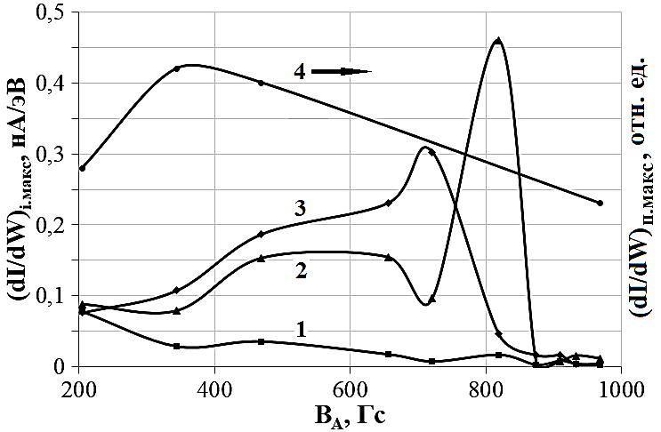Fig. 1. dI/dW_{i.max} = f(B_{A}) for Ne⁺ ions (curve 1), Ar⁺ (2), Kr⁺ (3) and a sample from the total ion energy distribution (4) of the magnetic field induction value at the TAL anode; discharge voltage U_{d} = 1100 V; P = 15⋅10⁻⁵ Torr; gas inlet velocity q_{Ne} = 10 sccm; q_{Ar} = 10 sccm; q_{Kr} = 10 sccm.
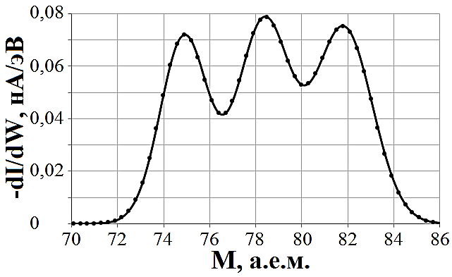
Fig. 2. Fine structure of the distribution of Kr⁺ ions by energy (velocity-mass) inside the ΔW Wine filter of the TANDEM analyzer.
The use of a TANDEM allows you to “unplanned” see the “fine structure” of signals from ions of each class in the energy window determined by the energy resolution ΔW of the analyzer. Figure 2 shows an example of a signal generated on the analyzer collector by krypton ions. The same physical nature of this structure is seen with the isomagnetic jumps observed earlier [3] on the total ion distribution function measured by the RFA.
References
- Bardakov V.M., Kichigin G.N., Strokin N.A., Tech. Phys. Letters, 2010, 36, 185.
- Strokin N.A., Bardakov V.M., Nguyen The Thang, and Kazantsev A.V., Tech. Phys. Letters, 2020, 46, 466.
- Strokin N.A., Kazantsev A.V., Bardakov V.M., The Thang Nguyen, and Kuzmina A.S., Physics of Plasmas, 2019, 26, 073501.

*) abstracts of this report in Russian

