Evolution of the glow intensity of damped plasma channels under the expulsion effect *)
DOI: 10.34854/ICPAF.2021.48.1.136
I.A. Znamenskaya, D.I. Tatarenkova, T.A. Kuli-zade
Lomonosov MSU, Physics department, znamen@phys.msu.ru
The effect of a dielectric insert on the evolution of the glow intensity of a pulsed high-current surface discharge in air was studied. The sliding discharge (plasma sheet) was initiated on a 30 mm × 100 mm surface with a dielectric ledge (48 mm × 6 mm × 2 mm) located parallel to the direction of development of the discharge channels, as shown in figure 1. The surface discharge had a multi-channel structure: it was a set of parallel plasma microchannels 30 mm long, distributed over a dielectric surface 100 mm long. It is shown that the presence of the ledge distorts the initially homogeneous diffuse glow of the discharge. Discharges on a profiled surface have already partially found their application, for example, for igniting fuel and flame holding [1].
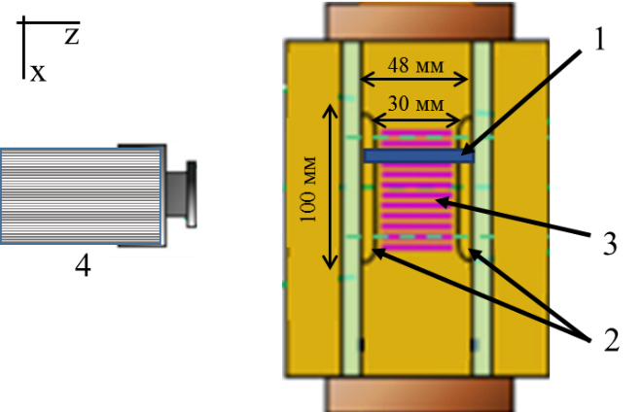
Figure 1 shows a diagram of an installation with the ledge (1) that was installed on a dielectric surface with electrodes (2). The high-current sliding discharge (3) was realized between the electrodes using a generator that outputs a rectangular pulse to the spark gap with a voltage amplitude of 15-30 kV and a duration of 100-300 ns. The analysis of the glow was carried out using integral photographs from a digital camera, as well as images obtained by a Bifo K011 electron-optical camera (4), which is designed to record images and measure space-time parameters in the nine-frame shooting mode of the recorded image. The minimum shooting exposure is 100 ns, the minimum time between frames is 100 ns.
Figure 1. Installation diagram
The obtained images show the evolution of the glow intensity distribution of the damped plasma channels near the ledge in the time interval up to 5 microseconds.
The study was carried out with the support of the RFBR (project No. 19-08-00661).
Reference
- Y. Ju; W. Sun, (2015). Plasma assisted combustion: Dynamics and chemistry. Progress in Energy and Combustion Science, 48(), 21–83.

*) abstracts of this report in Russian

