GLOW OF MICROPLASMA DISCHARGE ON THE SURFACE OF TITANIUM, COVERED WITH THIN CONTINUOUS DIELECTRIC FILM, WITH a TOTAL ELECTRIC CURRENT OF 50 A *)
DOI: 10.34854/ICPAF.2021.48.1.157
Ivanov V.A., Konyzhev M.E., Kamolova T.I., Dorofeyuk A.A.
A.M. Prokhorov General Physics Institute, Russian Academy of Sciences, Moscow, Russia ivanov@fpl.gpi.ru
It is well known that the flow of dense plasma in a vacuum can initiate microplasma discharges (MPDs) on the surface of a metal sample covered with a thin dielectric film [1]. These discharges result from an electric discharge (breakdown) between the outer surface of the film charged in the plasma flow and the open surface of the metal [2, 3].
In this work, we experimentally studied the spatial structure of the glow (in the optical wavelength range) of pulsed MPDs of various durations (400–1600 µs), excited on the titanium surface (Grade-4), covered with a thin dielectric film of 2–10 nm. These discharges were initiated on the titanium surface by pulses of "seed" dense plasma: the concentration of electrons in the plasma is 2×10¹³ cm^{─3}, the electron temperature is 10 eV, and the pulse duration is 25 μs. At subsequent moments of time, the propagation of the MPD on the titanium surface was supported by an external source of pulsed electric current and voltage (50 A, –400 V) (Fig. 1).
The titanium sample was a grinded plate 20×20×0.6 mm³ in size. In this case, a dielectric titanium dioxide film with a thickness of about 2–10 nm was naturally formed on the titanium surface in an air atmosphere at room temperature. After that, the titanium sample was installed in a vacuum chamber at a distance of 2.5 cm from the "seed" plasma injector.

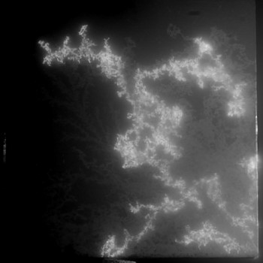 | Figure 1. Integral photograph of the glow of a single MPD on the surface of a titanium plate 20×20×0.6 mm³, covered with a thin continuous dielectric (titanium dioxide) 2–10-nm-thick film.  MPD parameters: the amplitude of the total electric current of the discharge is 50 A, the duration of the discharge pulse is 1600 μs, and the characteristic velocity of the discharge propagation is 15 m/s.  The spatial structure of the MPD glow on the titanium surface was registered with a Nikon D7100 digital camera and a Nikkor AF-S Micro 105mm/2.8 G ED macro lens.
It was found that the glow of the microplasma discharge visually on a macroscale has a branched structure of the dendrite shape, which on a microscale consists of a large number of brightly glowing “point” formations – cathode spots localized on the titanium surface. It was found that the MPD (discharge current 50 A, voltage applied to the sample –400 V, pulse duration 400–1600 μs) propagates over the titanium surface, covered with a thin continuous dielectric film with a thickness of ~10 nm, at an average velocity of 15 m/s. In this case, the propagation of the MPD on a microscale has a “jumping” character: the plasma of “motionless” burning cathode spots initiates the excitation of new cathode spots at a localization distance of ~10 μm from them [3].
References
- Ivanov V.A., Sakharov A.S., Konyzhev M.E., Plasma Physics Reports, 2008, V.34, No. 2, p. 150–161
- Ivanov V.A., Sakharov A.S., Konyzhev M.E. et al., Journal of Physics: Conference Series 907 (2017) 012023 https://iopscience.iop.org/article/10.1088/1742-6596/907/1/012023/pdf
- Ivanov V. A., Konyzhev M. E., Dorofeyuk A. A. et al., Journal of Physics: Conference Series 1647 (2020) 012018 https://iopscience.iop.org/article/10.1088/1742-6596/1647/1/012018/pdf

*) abstracts of this report in Russian

