Interaction of GAM and broadband turbulence in plasma of t-10 tokamak*)
DOI: 10.34854/ICPAF.2021.48.1.052
^{1,2}Krokhalev O.D., ^{1,2,3}Melnikov A.V.
¹NRC “Kurchatov Institute”, Moscow, Russia, nrcki@nrcki.ru
²Moscow Institute of Physics and Technology, Moscow, Russia, info@mipt.ru
³National Research Nuclear University “MEPhI”, Moscow, Russia, info@mephi.ru
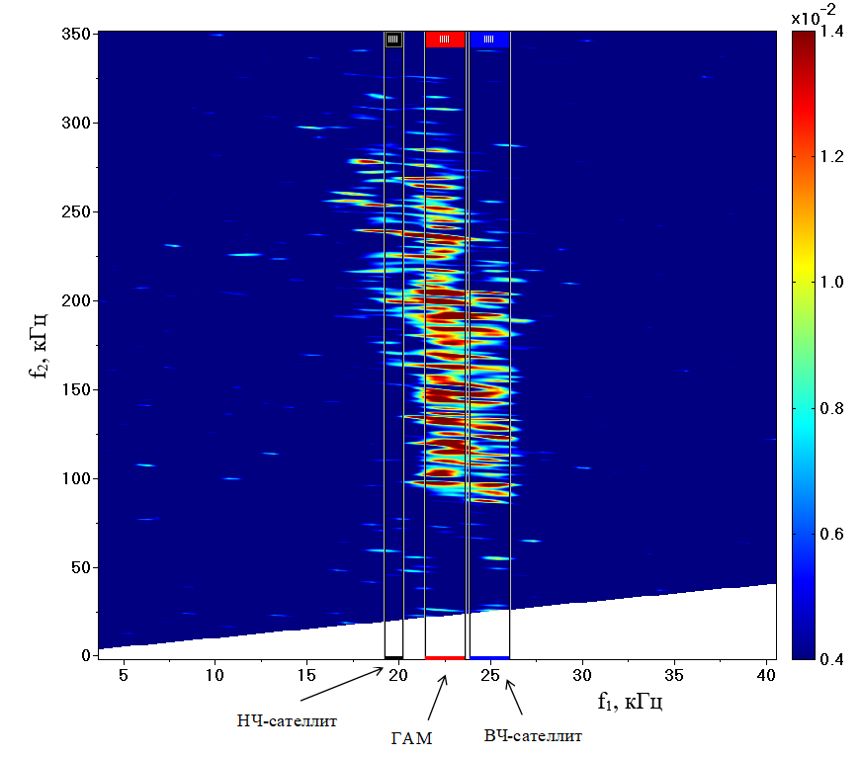
Geodesic acoustic modes – high frequency counterpart of zonal flows – are considered to be a possible mechanism of the plasma turbulence self-regulation in toroidal plasmas [1]. Study of structure of GUM and its interaction with broadband turbulence is impotant to understand physical mechanism of abnormal energy and particles transport [2]. Recent studies have shown that GAM consists of three frequency peaks: main peak an two satellites: low-frequensy and high frequensy [3]. The present research is focused on studying interaction of GAM and broadband turbulence using bicoherent analysis of data, received from heavy ion beam probe. Statistically significant value of cross-bicoherence quadric coefficient
Figure 1 – Cross-bicoherence $b_{\left(φ, I_{tot}, I_{tot}\right)}^{2}(f_{1}, f_{2})$
$b_{x,y,z}^{2}\left(f_{1}, f_{2}\right)= \frac{{|〈Φ_{x}\left(f_{1}\right)Φ_{y}\left(f_{2}\right)Φ_{z}^{*}\left(f_{1}+f_{2}\right)〉|}^{2}}{〈{|Φ_{x}\left(f_{1}\right)Φ_{y}\left(f_{2}\right)|}^{2}〉〈{|Φ_{z}\left(f_{1}+f_{2}\right)|}^{2}〉}$ (1)
is a mark of three-wave interaction between oscillations on frequencies f₁, f₂ and f₁+ f₂. In the formula (1) $Φ_{x}\left(f\right)$ means the Fourier transform of the signal x at the frequency f, $Φ_{x}^{*}\left(f\right)$ – its complex-conjugated quantity. Figure 1 shows cross-bicoherence quadric coefficient calculated for signals of plasma potential ϕ and density (total current of the ion beam I_{tot}) in the shot with low electron concentration (n_{e} ≈ 0.7 m⁻³).
Current study states that each of three peaks of GAM interacts with broadband turbulence with three-wave mechanism. Interaction has fine structure: each of three peaks corresponds to individual diapason of frequencies f₂. Main peak of GAM intereacts with wide frequency diapason of turbulence, LF-satellite interacts with high frequency part of it, HF-satellite – with low-frequensy part.

References
- Fujisawa A. et al, Experimental progress on zonal flow physics in toroidal plasmas, Nuclear Fusion 2007 47 (10) S718-S726
- Melnikov A.V. et al. Study of interactions between GAMs and broadband turbulence in the T-10 tokamak // Nuclear Fusion 2017, 57 (6) 115001.
- Krokhalev O.D., Melnikov A.V., GAM in plasma of T-10 tokamak: frequency structure and interaction with broadband turbulence. To be published in «JETP Letters»
- Melnikov A.V. et al. Heavy ion beam probing – diagnostics to study potential and turbulence in toroidal plasmas // Nuclear Fusion 2017 57 (6) 072004.

*) abstracts of this report in Russian

