METHODS AND RESULTS OF ABSOLUTE CALIBRATION OF MAGNETIC PROBES OF TOKAMAK T-15MD *)
DOI: 10.34854/ICPAF.2021.48.1.046
Stepin A.V., Balashov A.Y., Belov A.M., Igonkina G.B., Semenov P.S., Sokolov M.M., Sushkov A.V., Khayrutdinov E.N.
National Research Center "Kurchatov Institute", Moscow, Russia, steopin.andrei.@yandex.ru
Currently in the NRC “Kurchatov Institute” is preparing for the physical start-up of the tokamak T-15MD installation (R = 1.48 m, a = 0.67 m, k = 0.3 ÷ 0.4, Ip = 2 MA, B_{t} = 2 T, t_{dis} = 30 s) [ 1]. The T-15MD electromagnetic diagnostics system is an integral part of the T-15MD vacuum vessel (VV) and has more than two hundred inductive coils (magnetic sensors) of various sensitivity and with different geometric parameters for measuring both averaged and local values ​​of magnetic fields. Some of these sensors are involved in the real-time control system for the position and shape of the plasma.
The report considers local magnetic probes (49x42x23 mm3), which may be two field component sensors (TFS), registering the normal and poloidal components of the magnetic field; and single field component sensors recording the poloidal component, which are located both along the poloidal bypass of the VV (MHDP) and along the toroidal bypass of the VV (MHDT) [2]. The layout of the probes in VV T-15MD is shown in Fig. 1. TFS are represented by one array of 39 pcs., MHDP - by two arrays (39 pcs. In each) and MHDT - by one array (44 pcs.). All sensors are located inside the vacuum vessel. The sensors of the MHDT array are installed along the entire toroidal bypass of the tokamak vacuum chamber on its outer circumference, and the TFS and MHDP sensors are located approximately evenly along the poloidal bypass of the VV.
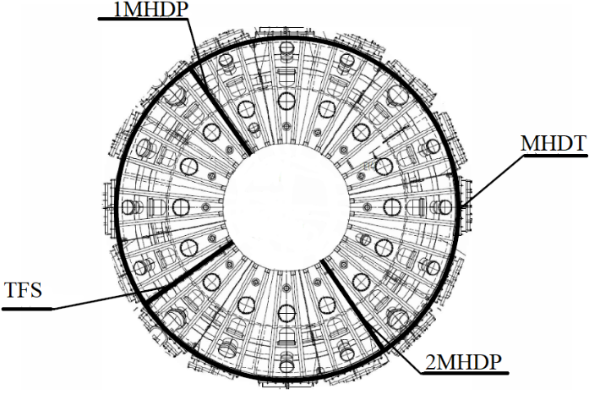
A special stand was created to carry out absolute calibration of the sensitivity of magnetic probes. The basis of this stand is made up of Helmholtz coils, with a uniform magnetic field created inside, where the reference coil is located together with the calibrated sensor. Each probe is calibrated with an error of no more than 0.1%. The calibration results showed that the averaged NS values ​​are ~ 160 cm² for coils that measure the normal component of the magnetic field, and ~ 120 cm² for coils that measure the poloidal component of the magnetic field. A database was created for the convenience of the calibration results storage.
Fig.1.
Layout of one-component and two-component magnetic probes in the T-15MD (top view).
References
- Khvostenko P.P., Anashkin I.O., Bondarchuk E.N. et al., VAST. Ser. Thermonuclear fusion, 2019, 42, release 1.
- A.V. Sushkov, A.M. Belov, G.B. Igonkina et al., Fusion Engineering and Design, 2019, 146, p.383-387.

*) abstracts of this report in Russian

