COMPARISON OF corpuscular AND OPTICAL DIAGNOSTICS IN A radioFREQUENCY LOW-PRESSURE DISCHARGE IN INERT GASES *)
DOI: 10.34854/ICPAF.2021.48.1.118
¹Kaziev A.V., ^{1,2}Kolodko D.V., ¹Ageychenkov D.G., ^{1,3}Sergeev N.S., ¹Kharkov M.M.
¹National Research Nuclear University MEPhI (Moscow Engineering Physics Institute),
Moscow, Russia
²V.A. Kotelnikov FIRE RAS, Fryazino, Moscow region, Russia
³NRC “Kurchatov Institute”, Moscow, Russia
Investigations of the ion flux composition in low-temperature plasmas of various gas discharges attract much attention keeping in mind the importance of ion-surface bombardment processes in many technological applications. In particular, a pressing problem is to diagnose ion fluxes in mixtures of process gases [1], or in the presence of different sort of ions in plasma in addition to the main ions [2].
Experiments on the diagnostics of the mass-resolved composition of plasma were carried out in Bella facility. Here, plasma is formed using a radiofrequency generator (13.56 MHz), which excites a planar coil. The produced plasma fills a fairly large volume (~ 30 l). For corpuscular diagnostics, a magnetic sector mass analyzer with a custom extraction system was used [3]. The maximum detectable mass for the accelerating voltage of 4 kV was 53 amu. A three-channel Avantes AvaSpec ULS2048L spectrometer was used for optical diagnostics.
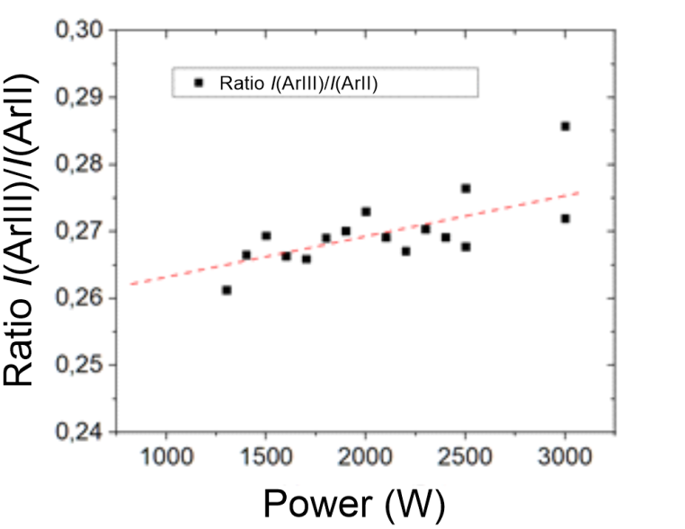
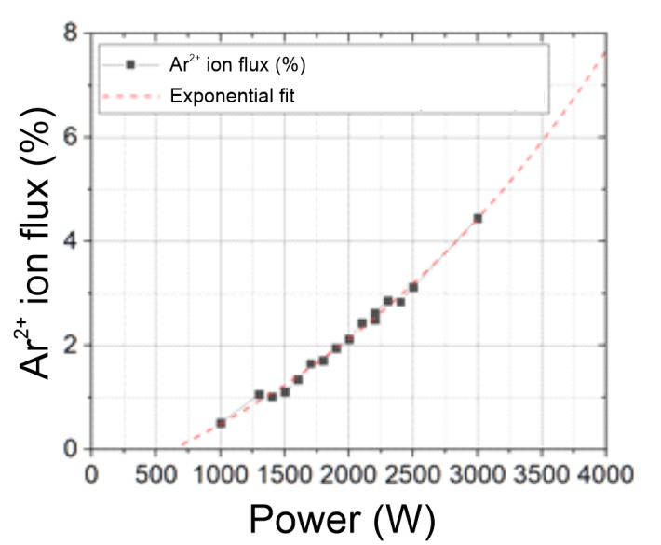
Several series of experiments were carried out. In the first series, a discharge in Ar was characterized at various pressures (3×10^{–4}–1×10^{–3} mbar) and power levels (700–2000 W). The behavior Ar⁺ and Ar²⁺ ion fluxes and the corresponding intensities of their spectral lines were studied. The measurement results for experiments with power variation are shown in Fig. 1.
Figure 1. Ar²⁺ ion fraction in flux from plasma (left) and intensity ratio of Ar⁺ и Ar²⁺ lines (right)
In the second series, a discharge was investigated in He/Ar and He/Ne mixtures with a fixed total pressure of 1×10^{–2} mbar at a power of 1700 W. A small Ar impurity in the main gas (He) leads to a significant Ar⁺ ion flux to the surface. If the impurity is Ne instead of Ar, this effect is not observed, and the fraction of Ne⁺ ions in the flux is close to the percentage of Ne gas in the mixture. This work was supported by the Russian Science Foundation (grant 20-12-00203).
References
- Kolodko D.V. et al. Journal of Physics: Conference Series 747 (2016) 012018
- Sorokin I.A. et al. Nuclear Materials and Energy 12 (2017) 1243–1247
- Kaziev A.V. et al. Journal of Instrumentation 14 (2019) C09004

*) abstracts of this report in Russian

