DIAGNOSTICS OF POSITIVE AND NEGATIVE ION fluxes IN THE REACTIVE MAGNETRON sputtering PROCESS *)
DOI: 10.34854/ICPAF.2021.48.1.119
¹Kaziev A.V., ^{1,2}Kolodko D.V., ¹Konaguru R., ^{1,3}Sergeev N.S., ¹Ageychenkov D.G.
¹National Research Nuclear University MEPhI (Moscow Engineering Physics Institute), Moscow, Russia
²V.A. Kotelnikov FIRE RAS, Fryazino, Moscow region, Russia
³NRC “Kurchatov Institute”, Moscow, Russia
It is well-known that nonlinear hysteresis effects are observed during the reactive magnetron deposition of oxide, nitride and other compound coatings if the content of the reaction gas in the mixture is varied [1]. These processes are of great importance for the characteristics of growing films, since they determine the stoichiometry and deposition rate. As a rule, optical emission spectroscopy is used to control the reactive sputtering processes. However, it is does not provide localized measurements of the ion fluxes of different sorts [2]. For this purpose, corpuscular diagnostics is an excellent choice.
Experimental diagnostics of the component composition of ion fluxes from the discharge plasma were carried out in a setup with a planar magnetron with circular 75-mm-diameter target (Pinch Magneto series). For corpuscular diagnostics, a magnetic sector mass analyzer with a custom extraction system was used [3]. The maximum detectable mass for an accelerating voltage of 1 kV was 140 amu. To increase the measurement sensitivity, a secondary electron multiplier connected to a picoammeter was used as a detector. The mass spectra were measured both in separate dedicated experiments and during the deposition of coatings.
A discharge with Al and Zr targets in Ar and O2 mixtures was studied with different oxygen content in the total gas flow and at different discharge power (100, 200, 300 W). The magnetron was operated either in direct current or in pulse-periodic mid-frequency (100 kHz) power modes. It was observed that an increase of the oxygen content in the gas mixture while maintaining constant total mass flow rate of Ar and O2 leads to a decrease in the fluxes of positive Ar+ ions and metal ions (Al+ and Zr+). An increase in the oxygen flow rate changes the ratio between them towards the prevalence of metal ions. Decrease of Ar+, O+, O2+, Al+, and Zr+ ion currents is accompanied by an increase of the negative O– ion current.
In case of pulsed modes, it is shown that with an increase in the pause duration for a fixed average discharge power, the absolute fluxes of metal and gas ions increase. This effect is illustrated in Fig. 1 for zirconium target.
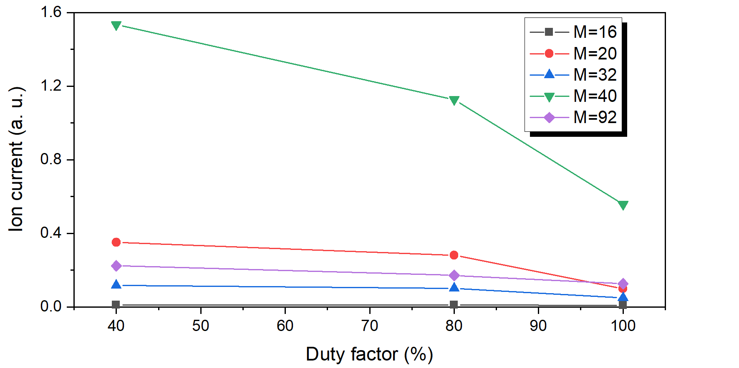
Figure 1. Dependence of fluxes of different ions on the duty factor
The study was supported by RFBR (grant no. 18-38-20185).
References
- Strijckmans K., Schelfhout R., Depla D. Journal of Applied Physics 124 (2018) 241101
- Sproul W.D., Christie D.J., Carter D.C. Thin Solid Films 491 (2005) 1–17
- Kaziev A.V. et al. Journal of Instrumentation, 14 (2019) C09004.

*) abstracts of this report in Russian

