Own ELECTRIC FIELD STRENGTH MODELING OF OF KEROSENE AND LIQUID OXYGEN COMBUSTION PRODUCTS PLASMA *)
DOI: 10.34854/ICPAF.2021.48.1.107
Rudinskii A.
Bauman Moscow State Technical University, ravman@bmstu.ru
The method for calculating the strength of the intrinsic electric field in a supersonic flow of partially ionized plasma in a channel with variable cross section is presented. The mathematical model uses the energy equation with source terms that describe the volumetric electric charge in the combustion products and the energy exchange of electrons and «heavy» particles (ions and electrically neutral molecules). The nozzle of the model liquid-propellant rocket engine (MLRE) [1] with a supersonic flow velocity at the outlet corresponding to the Mach number equal to 3 (Figure 1) was considered as a channel of variable cross-section. The distributions of the gas-dynamic parameters of the combustion products flow (pressure, temperature, velocity, etc.) were determined by solving the Navier-Stokes equations in the Ansys Fluent program with a k-ε turbulence model. The volumetric concentrations of charged particles (positively and negatively charged ions and electrons) in the combustion products were determined from the condition of thermodynamic equilibrium in the Terra program [2].
As a result of modeling, the distribution of the electric field strength along the axis of the nozzle in the plasma of combustion products liquid oxygen + kerosene was obtained (Figure 2).
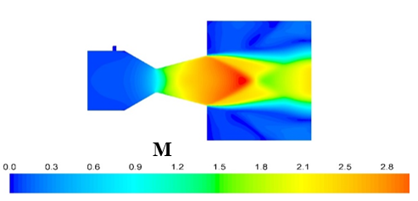 | 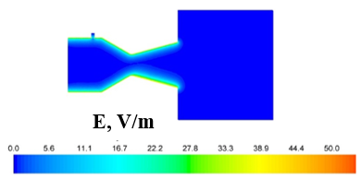
Figure 1 - Mach number | Figure 2 - Electric field strength
Under the conditions of a grounded MLRE, determination of the concentration of free electrons in the combustion products under the assumption of thermodynamic equilibrium and determination of the electrical conductivity coefficient under the assumption of neutral plasma [3], the maximum current density on the wall of the chamber under study was up to 200 mA/m² with the conductivity of the combustion products 4×10⁻³ Ohm⁻¹×m⁻¹, which corresponds to a maximum electric field strength of 50 V/m. The obtained results were compared in terms of the current value with the experimental data [4]. The results of mathematical modeling can be used in the development of a contactless system for diagnostics of the working process in a liquid-propellant engine.
This work was supported by Project No. 0705-2020-0044 of fundamental scientific research of Russian Federation Ministry of Education and Science.
References
- Rudinskii A.V., Yagodnikov D.A. Mathematical Modeling of Electrization of Particles of Acondensing Phase in High-Temperature Flow of Combustion Products // High Temperature, 2019, Vol. 57, No. 5, pp. 753–760.
- Trusov B.G. (International symposium on theoretical and applied plasma chemistry. Mater. Ples, 2002). 3. P. 217.
- Vorob'ev V.S., Bobrov A.A., Zelener B. V. Transfer coefficients in ultracold strongly coupled plasma. Physics of Plasmas 25, 033513 (2018).
- Nagel’ Yu. A. Electrical charging of engines in the efflux of combustion products. Experimental results // Technical Physics. 1999. Vol. 44. N 8. Pp. 918-922.

*) abstracts of this report in Russian

