An influence of electron beam on the intensities of Ar XVII and Ar XVIII lines emitted by pinch plasma *)
DOI: 10.34854/ICPAF.2021.48.1.087
Baronova Е.О., Vikhrev V.V.
NRC “Kurchatov institute”, 123182, Russia, Moscow, Kurchatov sq.1, baronova04@mail.ru
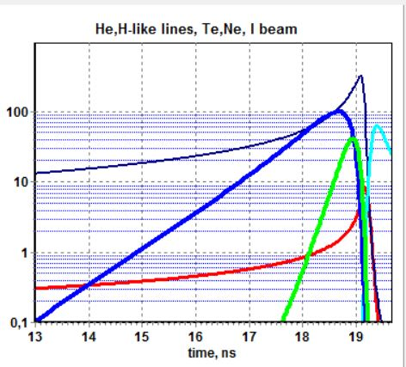
Relative intensities of helium - like and hydrogen - like lines are widely used to estimate electron density and electron temperature of hot and dense plasma. However those estimations need the information on the set of parameters, such as plasma optical density, presence of electron beams, electromagnetic fields, etc. For example, electron beams of specific energies might cause polarization of diagnostic lines as well as the variations in their intensity. How strong is the influence of electron beam depends on its energy and how much the life time of electron beam coincides with the life time of emission lines. Given study considers the influence of electron beam on the intensities of diagnostic lines in the frame of zero-dimensional model [1], where the plasma behavior is outlined from the beginning through the moment of maximal compression and up to the final cooling. Zero-dimensional model includes energy balance in which plasma energy is increased as a result of Joule heating and magnetic field energy, and it is decreased by radiation losses. Generation of electron beam is described in the frame of the model suggested by Dreicer [2]. Radiation losses take into account the following components: ionization, excitation, dielectronic recombination, radiative recombination losses and losses due to bremsstrahlung. The intensities of helium–like and hydrogen–like lines are described taking into account the processes in dense plasma (the exchange between levels). Model provides the time dependent behavior of plasma electron temperature and density together with the dynamics of electron beam and time dependent intensities of Ar VII and Ar XVIII - lines. The test of the model is carried out: theoretical data are well matched with experimental one, taken on plasma focus facility with 500 kA discharge current.
In fig.1 the dynamics of line emission (in blue and in green) together with the one for electron beam (in light green) are shown. The dynamics of electron temperature (in red, in keV) and density (in dark blue, in 10¹⁷cm⁻³) for the discharge current 500 kA. Obviously in this type of the discharge the influence of electron beam on Ar XVII and Ar XVIII line intensities is neglected. The creation and development of such models permits one to develop the present methods of diagnostics of hot dense plasma.
Literature.
- Вихрев В.В. Простая модель плазменного фокуса // Физика плазмы. 1977. Т. 3. C.981.
- Dreicer H., Electron and Ion runaway in a fully ionized gas I // Phys. Rev. 1959. V. 115. No2.238-249.

*) abstracts of this report in Russian

