Dynamics of a nanosecond surface sliding discharge in supersonic air flows with density gradients *)
DOI: 10.34854/ICPAF.2020.47.1.148
Mursenkova I.V., Kuznetsov A.Yu., Liao Yu., Sazonov A.S., Ulanov P.Yu.
M.V. Lomonosov MSU, Faculty of Physics; Moscow, RF; murs_i@physics.msu.ru
The importance of the study of discharges in high-speed air flows is determined by the development of methods of practical application of discharges for airflow control. When energy is inputted into the flow using a pulsed discharge, a rapid change in the state of the gas accompanies by the formation and movement of gas-dynamic discontinuities from the gas-plasma boundaries [1]. The non-stationary process of their interaction [1-3] leads to a change in the structure of the initial flow [1, 2]. The study of the characteristics of discharges in inhomogeneous flows is necessary to determine the mechanism of their influence on the flow.
The experiments were carried out on a shock tube with a discharge chamber [1, 3]. The Mach numbers of the shock waves were up to 5 and the flow Mach numbers were up to 1.7. Surface sliding discharges with an area of ​​100×30 mm² were initiated at a certain stage in the development of the gas-dynamic flow (Fig. 1). The discharges initiate at a pulsed voltage of 20-30 kV. The discharge current and radiation were analyzed. The discharge current reaches 1 kA; its duration is less than 500 ns. The regimes of the development of the discharge were studied in inhomogeneous supersonic flows including the front of a plane shock wave (a) or the region of the interaction of the oblique shock wave with the boundary layer (b, Fig. 1) or the zone of reduced density behind the wedge (c).

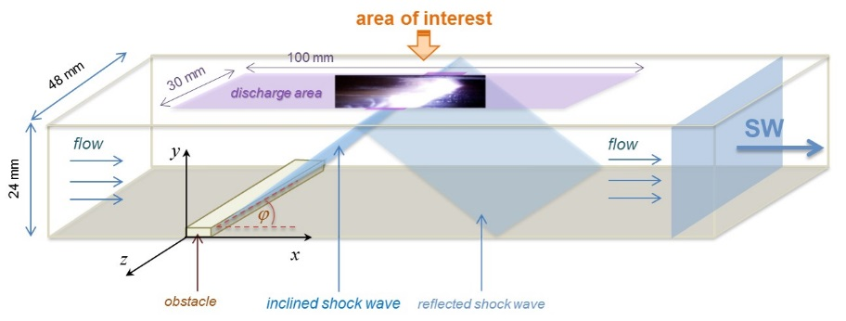
Fig. 1. Supersonic flow diagram in the channel of the discharge chamber with an obstacle
The experiments showed that the inhomogeneity of the density field in a supersonic airflow leads to the concentration of a surface sliding discharge into the channels of high local conductivity near the zones of reduced density. The spectrum and dynamics of the radiation of current channels are determined by the character of the interaction with gas-dynamic discontinuities. As a result, the spatial distribution of the energy deposition in the near-wall flow is substantially inhomogeneous, in contrast to that realized when initiating a distributed surface sliding discharge in homogeneous airflows [1].
The Russian Foundation for Basic Research supported the work (Grant No. 19-08-00661).
References
- Mursenkova I.V., Znamenskaya I.A. and Lutsky A.E. Influence of shock waves from plasma actuators on transonic and supersonic airflow. J. Phys. D: Appl. Phys., 2018. Vol. 51, No 5. 105201.
- Houpt A., Hedlund B., Leonov S., Ombrello T., Campbell C. Quasi-DC electrical discharge characterization in a supersonic flow. Exp. Fluids, 2017. Vol. 58. 25.

*) abstracts of this report in Russian

