STUDY OF ANOMALOUS TRANsport OF TUNGSTEN IONS IN DISCHARGES WITH ECR-HEATING ON THE T-10 *)
DOI: 10.34854/ICPAF.2020.47.1.054
¹Klyuchnikov L.A., ¹Krupin V.A., ^{1,2}Zemtsov I.A., ¹Nurgaliev M.R., ¹Nemets A.R., ¹Dnestrovskij A.Yu., ¹Solovev N.A., ¹Sergeev D.S., ¹Sarychev D.V., ¹Trukhin V.M., ¹Myalton T.B., ¹Borschegovskij A.A.
¹NRC «Kurchatov Institute», Moscow, Russia, kluchnikov_la@nrcki.ru
²Bauman Moscow State Technical University, Moscow, Russia
In experiments on T-10 with the electron-cyclotron resonance heating tungsten was removed from the center of the plasma cord [1] measured by the AXUV diagnostics. In cases where the removal took place according to the exponential law, the prediction of the experimental dynamics in the transport model makes it possible to estimate the tungsten transport coefficients. For this, a system of two continuity equations (dynamic and stationary) is solved:
(1)
where n_{W} is the total tungsten ions density, D and V are the diffusion coefficient and pinching velocity, Q_{W} is the sum of sources and sinks (Q_{W} ≈ 0 for the central plasma region). The solution is carried out by selecting such D(r) and V(r) that allow us to achieve the best description of the AXUV signal time evolution.
Equations are solved using the STRAHL code integrated in the ASTRA code. Transport coefficients are considered as the sum of neoclassical and anomalous parts: D = D^{neo} + D^{an} and V = V^{neo} + V^{an}. Neoclassical part is calculated using the NEOART code.
An example of a dynamics description in a discharge with central ECR-heating with a power of P_{EC} = 0.75 MW is shown in Fig. 1. The time evolution of the central chord for AXUV is given in Fig. 1 (a). The description is carried out with the coefficients D and V shown given in Fig. 1 (b)-(c). The characteristic decay time is τ_{exp} ≈14 ms. As can be seen, such a time can be obtained by adding diffusion at the level of 1.5-2 m²/s to the ohmic level. The pinch term in this case turns out to be practically zero up to the middle of the plasma cord.
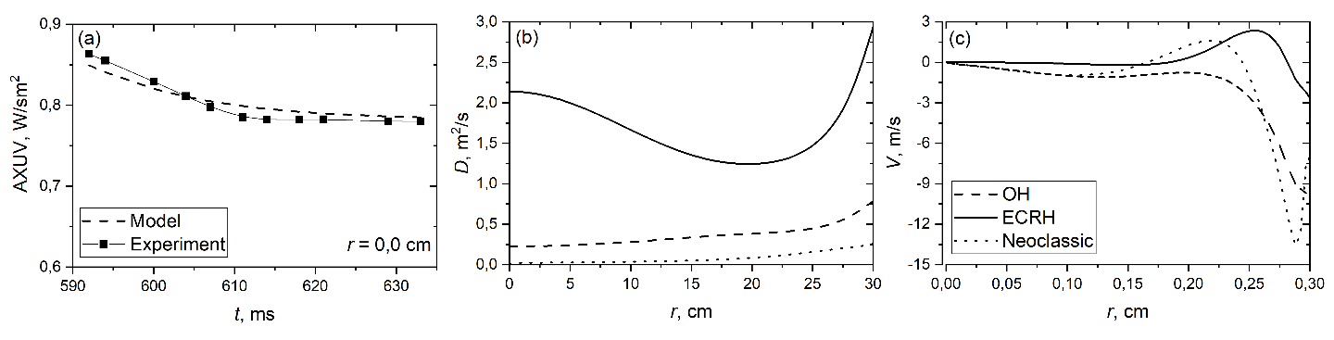
Fig. 1. Results of calculations for discharge 70358: (a) description of the dynamics of the AXUV for the central chord, (b) diffusion coefficients, (c) pinching velocity
Thus, the introduction of ECR heating leads to the removal of tungsten from the center of the plasma mainly due to an increase in anomalous diffusion. The results obtained, however, do not exclude the possibility of the existence of the convective removal of W from the plasma center in the ECR regimes. Further research is required for a more definite answer.
References
- V.A. Krupin et.al. Nucl. Fusion 57 (2017) 066041 (9pp)

*) abstracts of this report in Russian

