STATIONARY PLASMA CONFIGURATIONS IN A TOROIDAL TRAP IN THE TWO-FLUID MHD APPROXIMATION (MOROZOV-SOLOVYOV EQUATIONS) [1]*)

DOI: 10.34854/ICPAF.2020.47.1.043

Savelyev V.V.

Keldysh Institute of Applied Mathematics RAS, Russia, Moscow, ssvvvv@rambler.ru

The complete set of relations constituting the Morozov-Solovyov equation (MS-equation) is given in [1,2,3]. We consider the case of quasineutral plasma and consider the plasma to be at rest on average. The basic equations are written in terms of two functions - the magnetic flux function  and the total current function -



Here is the energy integral (Bernoulli integral) of electrons,  is the angular momentum integral of electrons, and  is the entropy of electrons. These three functions are constant along the electron current lines and must be given.

The finite element method is used to calculate a number of variants for different trap geometries and physical parameters.

As an example, we present the results obtained in the calculations for a trap with a D-shaped cross-section. The level lines of function *J* (electron current lines), magnetic field lines and electron pressure level lines are presented.

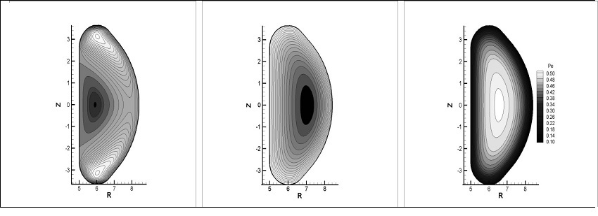

The study was supported by the Russian science Foundation (grant No. 16-11-10278). The author is grateful to M. B. Gavrikov for useful discussions.

References

1. A. I. Morozov and L. S. Solovyev, in Reviews of Plasma Physics, Ed. by M. A. Leontovich (Consultants Bureau, New York, 1980), Vol. 8, p. 1.
2. A. I. Morozov, Introduction to Plasma Dynamics (Fizmatlit, Moscow, 2006; CRC, Boca Raton, FL, 2012).
3. Savelyev V.V. Plasma Physics Reports, 2019, Vol. 45, No. 1, pp. 63–68.

1. *) [abstracts of this report in Russian](http://www.fpl.gpi.ru/Zvenigorod/XLVII/Mu/ru/AZ-Savel'ev.docx)