NUMERICAL SIMULATION OF SPARK DISCHARGE IN GAS-DYNAMIC FLOWS *)
DOI: 10.34854/ICPAF.2020.47.1.214
¹Ermakov E.A., ^{1,2}Ivanov I.E., ¹Katysheva V.V., ³Kryukov I.A., ¹Mursenkova I.V.
¹M.V. Lomonosov MSU, Faculty of Physics; Moscow, RF, murs_i@physics.msu.ru
²MAI, Moscow, RF
³IPMech RAS, Moscow, RF
The goal of the work is a numerical investigation of the laws of the formation of streamers and spark discharges in centimeter-gap gaps at atmospheric and higher gas pressures, taking into account the effects of the discharge on the gas-dynamic flow.
The plasma dynamics in the discharge gap in the two-dimensional (axisymmetric) case is described using the continuum diffusion-drift model (multi-fluid continuum, i.e. electron and ionic liquids). The dynamics of the gaseous medium (gas from neutral molecules) is described by the system of Euler equations. Both models are calculated together using the Godunov method of high order of accuracy. Figure 1 shows the numerical solution of the conjugate problem of the propagation of a streamer-spark discharge taking into account the energy input from the discharge into the gas phase. Gas is nitrogen at atmospheric pressure. The length of the inter-electrode gap is d = 0.6 cm and the width of the calculation region is r = 0.1 cm. The applied pulse voltage is U = 25 kV. The scheme of a computational experiment, where a cloud of electrons is set to replace the needle cathode in the calculation at the initial time, is shown in Fig. 1a. In fig. 1 b, c, d the electron density fields are shown at time points 2, 4, and 8 ns, illustrating the dynamics of the streamer growth taking into account the secondary emission of electrons from the cathode.

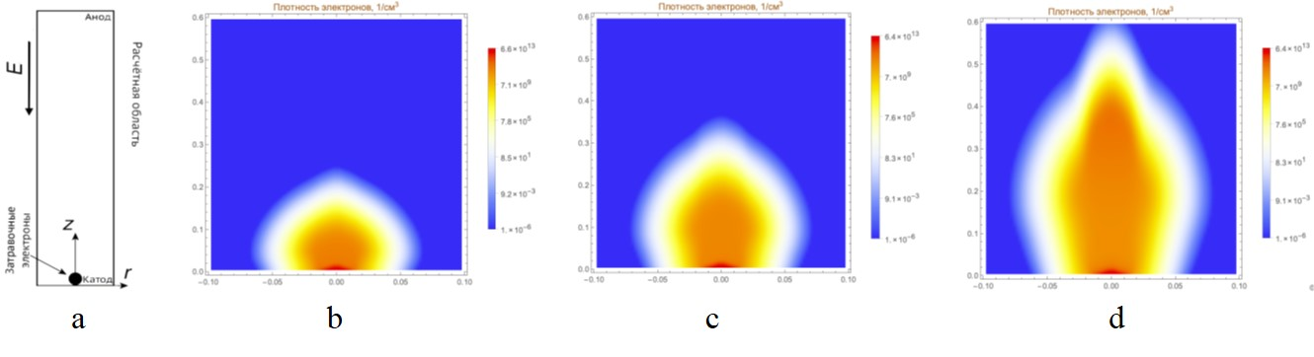

Fig. 1. a) Diagram of the computational domain for an anode-directed streamer; b), c), d) electron density (cm⁻³) taking into account electron emission from the cathode at t = 2, 4 and 8 ns.
An experiment is simulated numerically to study the hydrodynamic and thermal effects of nanosecond discharges in air [2]. A spark and pulsed nanosecond discharge in gas-dynamic flows with a complex shock-wave structure were considered [3].
References
- G. Glushko, I. Ivanov, I. Kryukov. Computational method for turbulent supersonic flows. Math. Models Comput. Simul., 2010. Vol. 2. No 4. P. 407-422.
- D.A. Xu, M.N. Shneider, D.A. Lacoste, C.O. Laux. Thermal and hydrodynamic effects of nanosecond discharges in atmospheric pressure air. J. Phys. D: Appl. Phys., 2014. Vol. 47. 235202.
- I.V. Mursenkova, Yu. Liao, I.E. Ivanov, N.N. Sysoev. The characteristics of a nanosecond surface sliding discharge in a supersonic airflow flowing around a thin wedge. Moscow University Physics Bulletin, 2019. Vol. 74. No 3. P. 269–276.

*) abstracts of this report in Russian

