nonlinear absorption of alphen wave by dissipative plasma with photorecombination radiation *)
DOI: 10.34854/ICPAF.2020.47.1.125
^{1,2}Gavrikov M.B., ³Pestryakova N.V., ¹Taiurskii A.A.
¹Keldysh Institute of Applied Mathematics RAS, Moscow, Russia, tayurskiy2001@mail.ru,
²Bauman Moscow State Technical University, Moscow, Russia, mbgavrikov@yandex.ru,
³FRC “Computer Science and Control” of RAS, Moscow, Russia, pestryakova@isa.ru
This work is a continuation of the earlier study [1] of nonlinear absorption of an Alfven wave by dissipative plasma due to dissipative effects and bremsstrahlung and photorecombination radiation. Studies were carried out on the basis of equations of electromagnetic hydrodynamics of two-fluid plasma [2]. The ratio between photorecombination and bremsstrahlung has the form [1]:
As shown in [1], for low amplitudes of the Alfven wave, heating to several thousand degrees occurs, the proportionality coefficient in this case should be taken equal to 3.33. For higher amplitudes and temperatures of the order of magnitude, as shown in this paper, the coefficient is taken equal to 371.2. For higher temperatures, photorecombination radiation can be neglected. Thus, the heating process substantially depends on photorecombination radiation, but, as our study has shown, this dependence is quantitative. The main conclusions remain the same as in [1]. The absorbed Alfvén wave penetrates to a finite depth less than when only bremsstrahlung radiation is taken into account. The parameters of the absorbed Alfven wave enter the quasistationary regime. Electrons and ions with additional allowance for photorecombination radiation are heated to a temperature lower than when only bremsstrahlung radiation is taken into account.
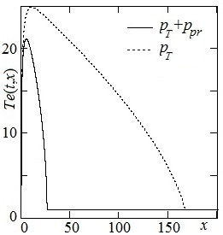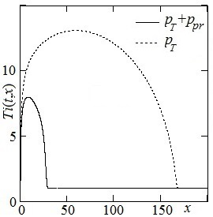
Fig. 1 Steady temperature profiles of electrons and ions for amplitude 1.
The study was performed by the grant from the Russian Science Foundation (project №16-11-10278).
References
- Gavrikov M.B., Taiurskii A.A. Influence of synchrotron and photorecombination radiation on absorption of Alfven wave by dissipative plasma // Matematicheskoe modelirovanie, 2013. T. 31. № 12. P. 71-85.
- Gavrikov M.B. Dvukhzhidkostnaia elektromagnitnaia gidrodinamika. M.: KRASAND, 2018. 584 p.

*) abstracts of this report in Russian

