The solution of the inverse problem to find anomalous conductivity of the plasma along the middle line in
A Hall thruster channel *)
DOI: 10.34854/ICPAF.2020.47.1.121
Tyushev M., Shashkov A., Lovtsov A.
Keldysh Research Center, Moscow, Russia, tyushev@phystech.edu
The experimentally observed value of discharge current in the Hall thruster (HT) [1] is significantly higher than the current described by classical conductivity. The conductivity addition that explains the observed current is called anomalous conductivity. Recent works show that the mechanism of anomalous conductivity is essentially three-dimensional. For the direct approach, a 3D PIC must be used, but this is impossible with the current level of computing resources. That’s why for the HT modeling an approximate conductivity models have to be used. Most often, the Bohm model is used [2], which has the anomalous collision frequency proportional to the electron cyclotron frequency. However, the experiments that were conducted in the work [3] show that the shape of anomalous conductivity significantly differs from the Bohm model. Nowadays, to increase the accuracy of models the experimentally measured profile of the anomalous conductivity must be used.
In this work, the method has been developed that allows one to find the profile of the anomalous conductivity using easily measurable integral data of the HT (discharge current and thrust). The main idea of the method is to find the best profile of the anomalous conductivity using Gaussian process [4]. The shape of the anomalous conductivity function was defined by 10 parameters, that were used for the approximation of the experimental data in work [6]. For calculations the 1D hybrid model was used, which is represented in work [6].
As a result, the more accurate fit for the experimental data was obtained. In the picture, one can see the difference in the local parameters between the five-zone and the one-zone models.
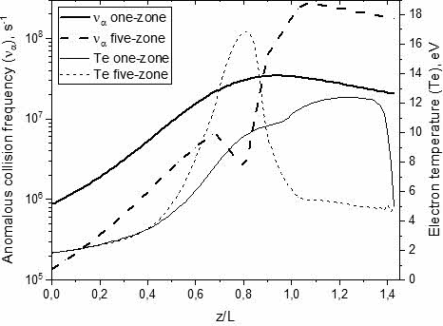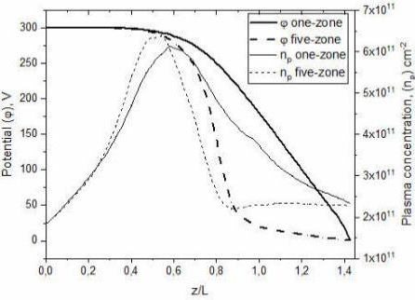
The dependences of the anomalous collisions frequency, electron temperature, potential, plasma concentration from the coordinate normalized on channel length.
References
- Morozov A.I., Kislov A.Ya., Zubkov I.P. Letters to ZhETF. Vol. 7., p. 224 (1968).
- D. Bohm, edited by R. Walkering, A. Guthrie (McGraw-Hill, NY, 1949), Vol. I, pp. 1-79
- J.A. Linnell, A.D. Gallimore, in 31st IEPC, Ann Arbor, p. 105 (2009)
- C. E. Rasmussen and C. K. I. Williams The MIT Press, 2006. ISBN 0-262-18253-X.
- I.G. Mikellides, A.L. Ortega, Plasma Sources Sci. Technol.28, 014003 (2019)
- Shashkov A., Lovtsov A., Tomilin D. Physics of Plasmas 24, 043501 (2017)

*) abstracts of this report in Russian

