Investigation OF switching CHARACTERISTICS OF a LASER-TrIGgered gas switch WITH tunable DELAY via CHANGING THE SPARK-gap ignition angle *)
DOI: 10.34854/ICPAF.2020.47.1.113
Medvedev M.A., Oginov A.V., Parkevich E.V., Khirianova A.I.
P.N. Lebedev Physical Institute of the Russian Academy of Sciences, 53 Leninskiy Prospekt, 119991, Moscow, Russia, medvedevma@lebedev.ru
The laser spark in its parameters is identical to a conventional electric spark in a gas, but due to a powerful external source of preionization, it has an extremely small time (<< 1 ns) and spatial formation jitter [1,2]. Due to this fact, the laser spark turns out to be an excellent controllable commutator of electromagnetic energy flows of high power and density. Typically, a laser triggered spark gap (LTSG) represent a spark gap filled with gas at high pressure, which is ignited by a laser beam directed along or at a certain angle (the ignition angle) to the gap axis [3,4]. It is known that, depending on the ignition angle, the breakdown delay time and LTSG jitter can vary from hundreds of picoseconds to hundreds of nanoseconds or more. It should be noted that this effect is of considerable interest from an applied point of view, however, its detailed study has not been previously conducted. In this report, we present the results of preliminary studies of this effect. In particular, we made an attempt to determine qualitatively, without delving into the essence of the processes of plasma formation in the gap, the main dependences of the switching characteristics of the LTSG on the ignition angle of the spark gap. Based on the results of the work, an air switch with laser ignition was developed, which has a subnanosecond jitter and breakdown delay, adjustable in the range of ~ 0.1–10 ns by changing the ignition angle of the spark gap.
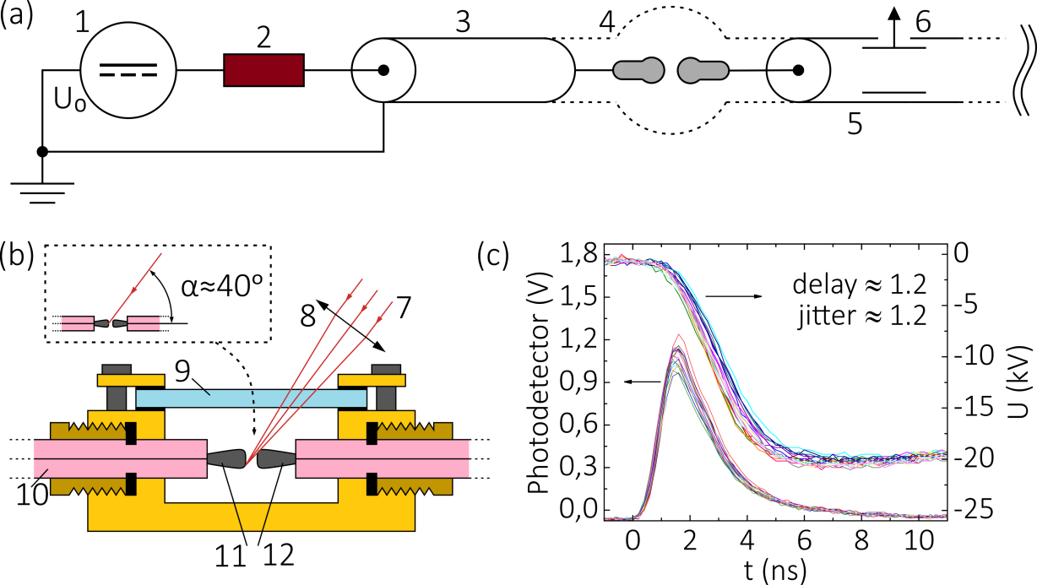
Figure 1. (a)–sketch of the experimental setup; (b)–desing of laser triggered switch; (c)–typical waveforms from photodetector and voltage divider.
This work was supported by the Russian Science Foundation grant No. 19-79-30086. The development of a laser-triggered arrester was partially supported by RFBR grant No. 18-32-00566.
References
- S. S. Harilal, Appl. Opt. 43, 3931 (2004).
- [W. D. Kimura, M. J. Kushner, E. Crawford, and S. Byron, IEEE Trans. Plasma Sci.A 14, 246 (1986)
- A. Larsson, IEEE Trans. Plasma Sci. 40, 2431 (2012).
- A. H. Guenther and J. R. Bettis, J. Phys. D: Appl. Phys. 11, 1577 (1978).

*) abstracts of this report in Russian

