Supercompact x-ray spectropolarimeter and its application for registration spectra from X-pinch *)
DOI: 10.34854/ICPAF.2020.47.1.093
Baronova Е.О.
National Research Centre “Kurchatov institute”, Moscow, Russia, baronova04@mail.ru
Registration of X-ray spectra is based on Bragg’s law 2d⋅sinθ = kλ (θ is the Bragg angle, λ and k are the wavelength and reflection order, respectively). The equipment for registration of x-ry spectra is usually designed by physisists. To design X-ray spectrometers the wavelength range, expected spectral resolution, the expected number of photons, detector type, the type of diagnostic chamber, the whole experimental geometry should be take into account. At the first stage of experiments the spectrometers with relatively wide wavelength range, so called survey spectrometers, should be used. In survey spectrometers the dispersive elements are flat and/or convex (de-Broglie type) crystals. In most of cases the spectrometers are mounted outside diagnostic chamber and require the usage of vacuum shutters and additional pumping. The distance between radiation source and the device is enough large, so the number of registered photons are sometimes small enough to be detected by traditional detectors.
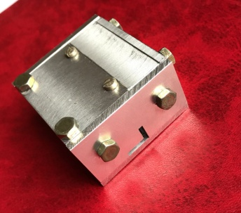
This paper suggests the survey spectrometer with very small sizes (length, width, height are close to 4 cm), so the device can be installed inside even very small plasma chambers improving the sensitivity of the method. Two convex mica crystals with curvature radius 1 cm are used with the dispersive planes mutually perpendicular to each other so that spectrometer is able to operate as spectropolarimeter in the vicinity of 14 and multiple to it. The filter is fixed at the entrance window of spectrometer to protect the detector from visible light. Traditionally the detector is film or “Imaging plates”. The code is designed to calculate dispersion, registered wavelength range, position of particular wavelength on the detector versus the plasma to crystal distance as well as the widening of lines versus the source size, etc. The device was used on an X pinch with the discharge current of 250 кА. Cu spectra belonging to L-series in the range 9–13.6 are presented. Sensitivity of spectrometer was enough to register spectra in single shot. The rough estimation of plasma electron temperature is given.
The advantages of super compact spectrometer are the small fabrication cost, simplicity of alignment, the possibility to use it to study not only plasma sources of x-ray spectra but also
X-ray tubes and other stationary sources of x-rays. Device can be used to educate students the basics of x-ray spectroscopy.

*) abstracts of this report in Russian

