IN-LINE PRODUCTION OF CRYOGENIC TARGETS FOR REALIZATION OF NATURE-LIKE TECHNOLOGIES IN IFE *)
DOI: 10.34854/ICPAF.2020.47.1.085
Koresheva E.R., Aleksandrova I.V., Koshelev E. L., Timasheva T.P.
P.N. Lebedev Physical Institute of the Russian Academy of Sciences, Moscow, Russia, koreshevaer@lebedev.ru
Working with moving cryogenic targets opens up the possibility for the practical implementation of nature-like technologies in the inertial fusion energy (IFE) systems for the production of environmentally safe fuels and the generation of electric and thermal energy.
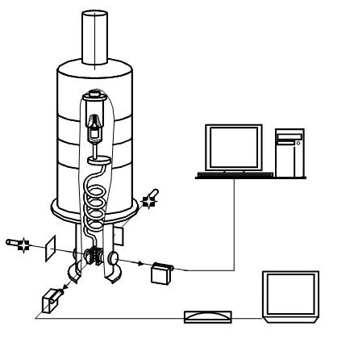
Fig.1. Schematics of the FST-layering module operation
(b)
After FST layering
the uniform ultrafine solid layer is formed

SC
LC
TC
Light

Light

Camera
Tomograph
Computers
Cryostat
This paper presents the results of the advanced research cycle obtained in the field of constructing a repeatable layering module for cryogenic targets production of a reactor-scaled design. The work is intended for mass manufacturing of IFE targets that is of specific science interest for the high-power laser community.
The principle of layering module operation is based on the FST (free-standing target) layering method [1, 2]: formation of a solid fuel layer inside free-standing and line-moving targets, which was proposed and developed at the Lebedev Physical Institute (LPI). Schematics of the FST-layering module operation is shown in Fig. 1.
The practical realization of this innovative technology will be the development of a prototype of a specialized-in-line FST-LM [3] of repeatable operation for the low-cost target production and their noncontact delivery at the focus of the reaction chamber of high repetition rate facilities or IFE reactor.
References
- Aleksandrova I.V., Koresheva E.R., Krokhin O.N., Osipov I.E. Cryogenic Hydrogen Fuel for Controlled Inertial Confinement Fusion (Formation of Reactor-Scale Cryogenic Targets). Physics of Atomic Nuclei, 79 (7), 1210-1232, 2016
- Aleksandrova I.V., Koresheva E.R., Koshelev E.L. FST-layering for application to high-gain direct-drive cryogenic targets. Proceedings of the XLV International Conference on Plasma Physics and Controlled Thermonuclear Fusion (Zvenigorod, Moscow Region, RF, April 2–5, 2018) http://www.fpl.gpi.ru/Zvenigorod/XLV/I.html#Sekcija%20I
- [Aleksandrova I.V., Koresheva E.R., Koshelev Е.L., Kuteev B.V., Nikitenko A.I. Mechanical mockup of IFE reactor intended for the development of cryogenic targets mass production and targets rep-rate delivery into the reaction chamber. In: Nuclear Fusion - One Noble Goal and a Variety of Scientific and Technological Challenges, 115-152, 2018

*) abstracts of this report in Russian

