PARAMETRIC INSTABILITY AND SUPERSTRONG MAGNETIC FIELDS GENERATION IN LASER PLASMA *)
DOI: 10.34854/ICPAF.2020.47.1.222
Skvortsov V.A.
Keldysh Institute for Applied Mathematics of the RAS
The results of computer simulations of an intensive laser beams interaction with metallic target in atmosphere of argon and hydrogen are represented with taken into account reflectivity, the diminishing of group light velocity in the vicinity of resonance absorption in non uniform plasma as well as effect of double refraction in anisotropic plasma in region of strong induced magnetic fields. It is shown that growth of magnetic field inductance takes place explosively for short time periods at the high level of inductance values of quasistatic magnetic fields on stage of laser intensity pulse growth. The examples of parametric instability (with the resonance) of quasistatic magnetic fields produced by picosecond laser beams (with the parameters: as in experiments [1,2]: wave length is about 1.06 μm, maximum intensity of main laser pulse in focal region I₀=7.2 ⋅10¹³ W/cm² in argon atmosphere near the aluminium target) are represented in Fig.1-3. It is seen that inductance of magnetic fields can rich a hundreds MG’s (up to 1-2 GG, as it was detected in X-ray spectroscopic measurements [2] on Zeeman’s splitting of line radiation of multiple charged ions of Ta-181). It is interesting that under more lower intensities of laser beams (for prepulses with I₀=2 ⋅10¹¹ W/cm²) it is possible a quasistatic magnetic fields generation with inductances up to 1 MG (see. Fig.4, on all figures the values max |B_{ϕ}(t)| are shown).
Fig.1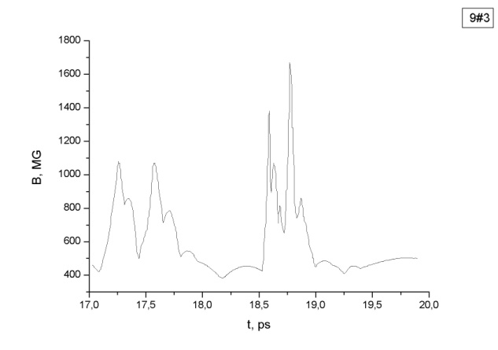Fig.2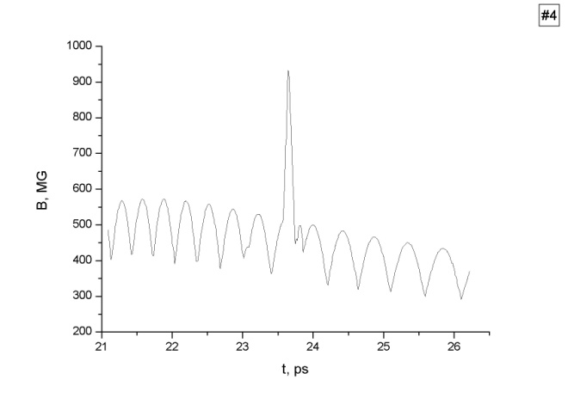
Fig.3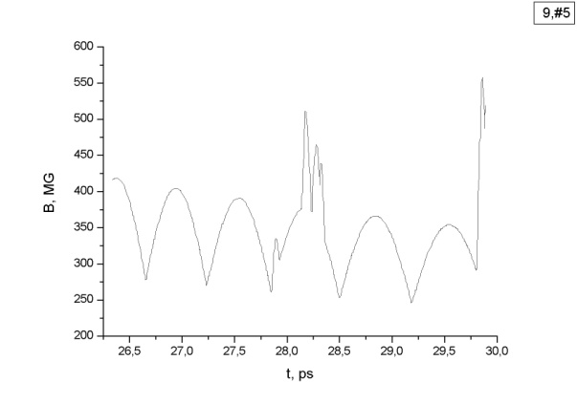 Fig.4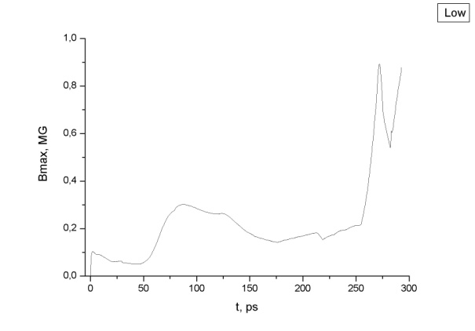
References
- Vogel N., Kochan N. Phys. Rev. Lett. 2001. Vol.86. No.2. P.232-235.
- Skvortsov V.A., Vogel N.I. The generation of superstrong magnetic fields in plasma of laser induced discharges. Proc. MEGAGAUSS XI International Conference , 2006. London. Published in VNIIEF, Sarov, 2009. Р.23–27.

*) abstracts of this report in Russian

