NEUTRON FIELD IN A FISSION REACTOR CORE WITH THE INNER FUSION NEUTRON SOURCE AT PULSE-PERIODIC OPERATING *)
DOI: 10.34854/ICPAF.2020.47.1.215
²Shamanin I., ¹Arzhannikov A., ²Bedenko S., ³Shmakov V., ³Modestov D., ³Serova E., ¹Prikhodko V., ²Polozkov S.
¹Budker Institute of Nuclear Physics SB RAS, Russia, tpu@tpu.ru
²National Research Tomsk Polytechnic University, Russia, inp@inp.nsk.su
³Russian Federal Nuclear Center – Zababakhin Institute of Applied Physics, Russia, vniitf@vniitf.ru
A calculation model and a program code were developed for studying three-dimensional fields of the neutron field and heat generation in the reactor system with a modified near-axial region (see Fig. 1) [1], operating sub-critically with an extended neutron source.
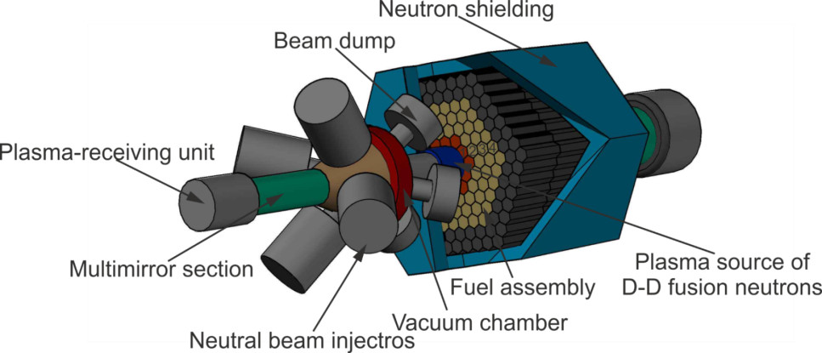
Fig. 1. Conceptual design of the hybrid reactor facility “fusion-fission”.
A long magnetic trap with thermonuclear plasma is operated as this extended neutron source. Our studies are conducted for a radially profiled reactor core consisting of local areas different from one another in the composition of nuclear fuel and containing elements to control and management its sub-criticality. The evolution of the sub criticality of the assembly and the nuclide composition of the fuel is studied at the pulse-periodic operating the hybrid system as well as the influence of these factors on the nuclear and technological safety of the reactor is analyzed. The results of the studies showed that to maintain k_{eff}(t) and P_{th} in the blanket of the reactor core system at the constant level the DD-neutron source should constantly supply the reactor core with neutrons, however the intensity of the DD-neutrons generation should grow gradually during the whole fuel-lifetime campaign. The generator of DD-neutrons which operates in the pulse-periodic mode should provide steady pulse duration equal to 0.1 ms for the “cold” reactor core. With respect to the suggested hybrid system it is required: 1. To choose composition and radial distribution of the starting loading with microencapsulated (Th,Pu)-fuel loading. 2. To provide the required conditions for start and generation of DD neutrons in the “cold” reactor core. 3. To choose the mode of the reactor core supply with additional neutrons from a thermonuclear source to achieve the conditions of P_{th} and k_{eff}=const in a long-time operational cycle.
The reported study was funded by RFBR, project number 19-29-02005 mk.
References
- A.V. Arzhannikov, A.V. Anikeev, A.D. Beklemishev, et al., 2016. Subcritical Assembly with Thermonuclear Neutron Source as Device for Studies of Neutron-physical Characteristics of Thorium Fuel. AIP Conference Proceedings. 1771, 090004. https://doi.org/10.1063/1.4964246.

*) abstracts of this report in Russian

