INTERACTION OF ATMOSPHERIC PRESSURE PLASMA WITH SURFACES
Babaeva N.Yu.
Joint Institute for High Temperatures Russian Academy of Sciences, Moscow, Russia, nybabaeva@gmail.com
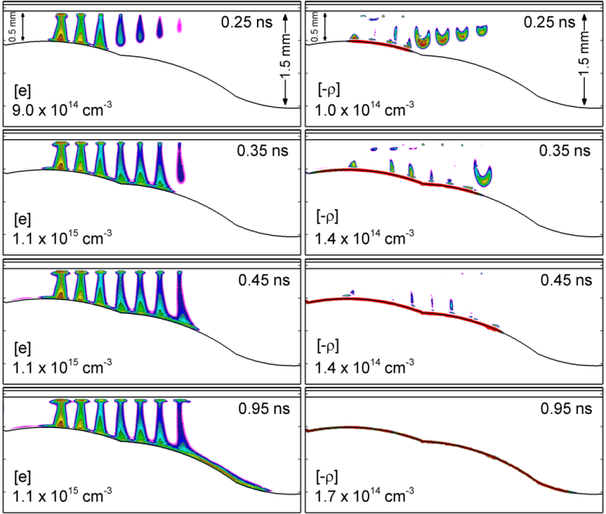
The direct use of atmospheric pressure plasmas, such as dielectric barrier discharges or plasma jets, in industrial or biomedical applications rely on delivery of active species to non-planar surfaces and remote locations. These surfaces are rarely flat and may have convex, concave or sloping topography, ranging from deep channels to deep cracks as might be encountered in deactivating bacteria or viruses. The common feature of these plasmas is the ability to propagate in a conformal manner along the surface. In this work, results from computational investigation of conformal propagation of plasma will be discussed. The computations were performed using a 2-dimensional plasma hydrodynamic model [1, 2].
We found that pulsed plasmas in the form of ionization waves conformally propagates along surfaces in a manner determined by the capacitive charging of those surfaces. Propagation is slowed in regions of high capacitance and speeds up in regions of low capacitance. As gas phase streamers charge surfaces, components of the electric field are produced parallel to the surface which directs the surface wave to uncharged regions. For example, DBD filaments which strike sloped surfaces are able to treat the surface uniformly (Figure 1). The streamer propagating along the surface is directed by electric fields oriented towards uncharged regions. Results will also be discussed for plasma propagation into high-aspect-ratio features such as cracks.

Figure 1. Electron density and space charges for simultaneously launched seven DBD filaments in air striking the surface and conformally propagating along the surface slope.

This work is supported by the Russian Foundation for Basic Research under Grant 17-52-53044.
References
- N.Yu. Babaeva, M.J. Kushner. Plasma Sources Sci. Technol. 23 (2014) 015007.
- N.Yu. Babaeva, G.V. Naidis, V.A. Panov, R. Wang, Y. Zhao, T. Shao. Physics of Plasmas, 25 (2018) 063507.

