MESOSPHERE AIR PLASMA PARAMETERS
Bychkov V.L., Ardelyan N.V., Kosmachevskii K.V., Maslov T.A.
Lomonosov Moscow State University, Moscow, Russia, bychvl@gmail.com
Studies related to the kinetics of air plasma in the Earth's mesosphere are of considerable interest from applied point of view. Information on the characteristics of air plasma at different altitudes is of great importance for the preparation of flight tests using various gas-discharge devices. From the point of view of the development of plasma devices for the new aviation and space technology at the heights of the troposphere and lower mesosphere, it is important to know the characteristics of the breakdown at altitudes in the range of 90–100 km. Interest in ionization processes at high altitudes is caused by the possibility of breakdown processes in the air near the surface of aircraft due to their electrification, or the appearance of atmospheric discharges, such as sprites, jets, etc. [1]. Plasma-chemical processes in the air at an altitude of 90–100 km are considered in the work; the background concentrations of the main charged particles are determined on the basis of numerical modeling under normal conditions.
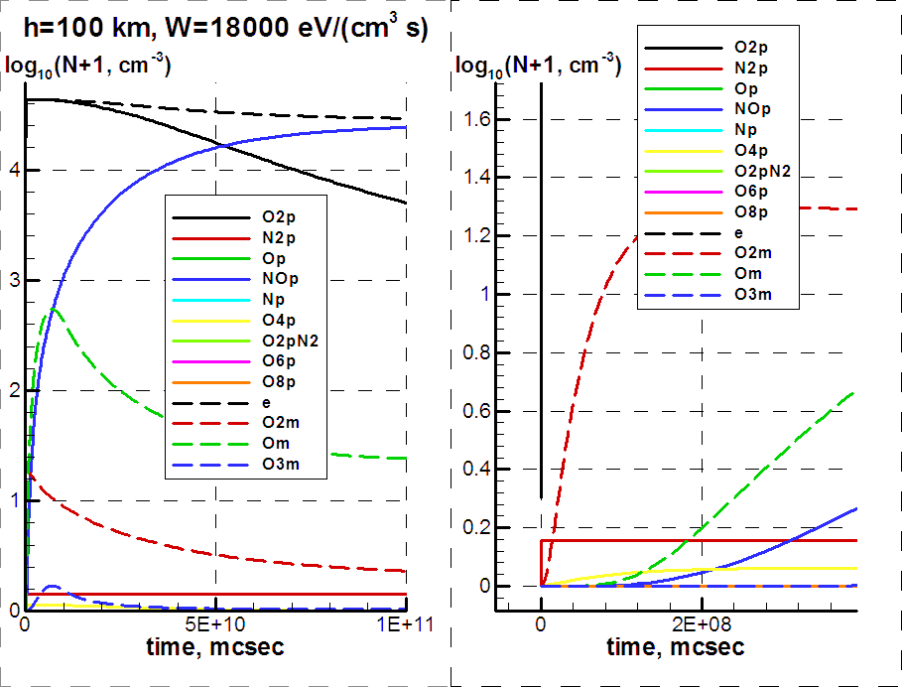
Fig.1.
To study the chemical kinetics of plasma in the air at altitudes of 90–100 km, we, as in our works [2, 3], used the system of chemical reactions corresponding to [2, 3] as the initial plasma-chemistry analysis of dry air. This model includes 26 components (neutrals, positive and negative ions, electrons and excited particles) and more than 180 plasma-chemical reactions with their participation. In this case, the energy distribution function of electrons was considered to correspond to a glow discharge in air. Figure 1 shows typical results of calculations.
References
- Brasseur G.B., Solomon S. Chemistry and physics of the Stratosphere and Mesosphere. D.Reidal publishing company. 1984. Dordrecht, Holland.
- Ardelyan N.V., Bychkov V.L., Bychkov D.V., Kosmachevskii K.V. Chapter 3. Electron-Beam and Non-Self-Maintained Driven Plasmas for PAC. In Plasma assisted combustion, gasification and pollution control. Vol.1. Ed. I.B. Matveev. Outskirts press. Denver, Colorado. 2013. P. 183–372.
- Ardelyan N.V., Bychkov V.L., Golubkov G.V., Golubkov M.G., and Kosmachevskii K.V. Influence of thunderstorm activity on the parameters of air plasma in the ionosphere. Russian Journal of Physical Chemistry B, 2018, Vol. 12, No. 4, p. 749–754

