NUMERICAL CALCULATIONs OF CAPACITIVE HF DISCHARGE IMPEDANCE IN A METAL VACUUM CHAMBER WITH INHOMOGENOUS FILLING
¹Dvinin S.A., ²Kodirzoda Z.A., ²Solikhov D.K.
¹Lomonosov Moscow State University, Faculty of Physics, Moscow, Russia,
dvinin@phys.msu.ru
²Tajik National University, Faculty of Physics, Dushanbe, Tajikistan, davlat56@mail.ru
Capacitive low pressure (ν << ω) high-frequency (HF) discharge with large area of electrodes, excited by an electromagnetic field with frequency 13.56–500 MHz in a metal discharge chamber, is supported by surface waves propagating along the plasma–sheath–metal interface [1–3]. The purpose of this work is numerical calculation of electromagnetic field distribution in the vacuum chamber, impedance and current-voltage characteristics of the discharge, when RF voltage is applied to active electrode and substrate holder. Resonances in the discharge under consideration can represent currents and voltages resonances in long lines, associated with the features of the radial RF field distribution or the geometric plasma-sheath resonance, related with compensation of voltages on the sheath and plasma [4].
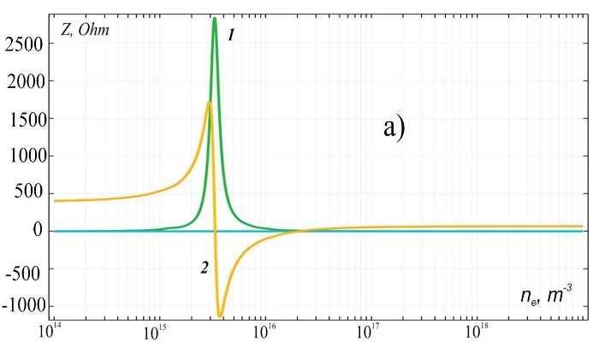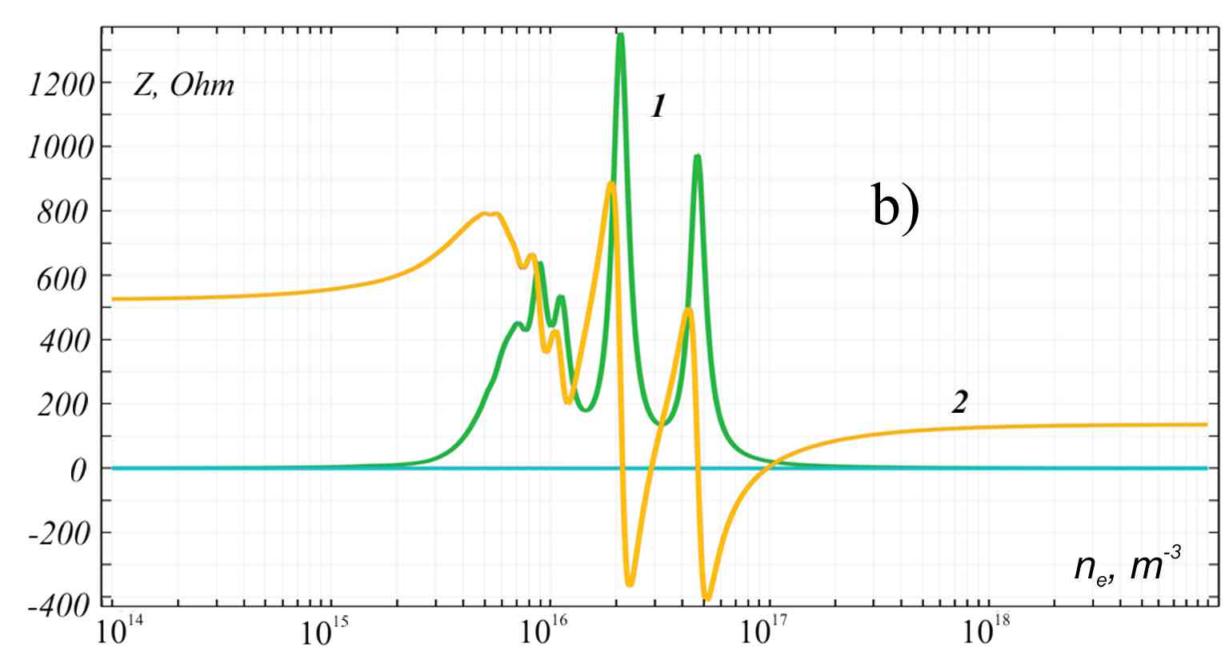
Fig. 1. Discharge impedance Z (1 ReZ, 2 ImZ) with symmetric (currents to the active electrode and substrate holder are equal and antiphase) – a) and antisymmetric excitation (currents of the electrodes close to the sidewall) as a function of density of electrons – b). Electric field frequency is 27.12 MHz.
An example of the obtained discharge impedance values is shown in Fig. 1. The dimensions of the active electrode and substrate holder are the same and equal to 20 cm, sheathes width at the electrodes are identical and were assumed to be equal to 3 mm in the calculation. In this case, either symmetric or antisymmetric surface waves [2] are excited. Calculations show that the dependences of the discharge impedance on the electron density under symmetric and antisymmetric excitation are qualitatively different even with symmetric electrodes and sheathes. In real conditions, the amplitudes of each wave will depend not only on the properties of the discharge, but also on the characteristics of the matching devices between the generators and the electrodes. The inhomogeneity of the plasma facilitates the excitation of resonant modes. The results allow determining the conditions for the optimal excitation of a discharge for the realization of a homogeneous plasma with a high electron density.
References
- Chabert P.J. Phys. D: Appl. Phys., 2007, 40, R63.
- Vologirov A.G., Dvinin S.A., Mikheev V.V. et al. Plasma Physics Reports, 2008, 34, p. 746.
- Dvinin S.A., Kodirzoda Z.A., Solikhov D.K., XLV International (Zvenigorod) Conference on Plasma Physics and Controlled Thermonuclear Synthesis, 2–6 April 2018, p. 293.
- Taillet J. American Journal of Physics, 1969, 37, 423.

