LASER–PLASMA SYNTHESIS UNDER THE CONDITIONS OF INTEGRATED EFFECT OF LASER PLASMA AND MICROWAVE FIELD
¹Medvedev A.E., ¹Pinaev P.A., ²Barnyakov A.M.
¹Institute of Laser Physics SB RAS, Novosibirsk, Russia, medvedev@laser.nsc.ru
²Budker Institute of Nuclear Physics SB RAS, Novosibirsk, Russia, skalpel@inbox.ru
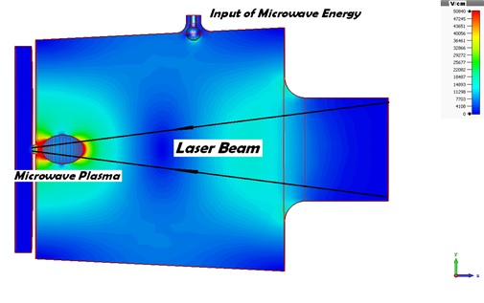
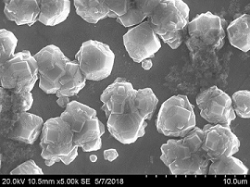
The operation of a setup based on a previously created microwave module [1, 2] and the newly developed quasi-cylindrical cavity in the TМ₀₁₂ mode is considered (Fig. 1). Unlike the traditionally used scheme of cylindrical cavity for microwave plasmatrons, when the cavity is divided by a quartz partition into a working chamber where plasma is formed and a microwave input chamber to prevent breakdown with higher gas pressure, our solution in the form of a quasi-cylinder allows laser beam input. A laser beam injected through an evanescent waveguide passes through a not very dense microwave plasma, forming a spot of near-surface laser plasma at the plasmatron output. The microwave module allows one to initiate microwave plasma synchronously with laser radiation pulses (1–5 μs, 30–150 kHz) with an adjustable phase (delay) and provides a basic background, reducing the ignition threshold and increasing the spot area of the laser plasma. Preliminary experiments have shown the operation of the microwave cavity and a possibility of synthesizing a diamond-like film on a molybdenum substrate (Fig. 2).
Fig. 1. Calculation of electric field configuration in a quasi-cylindrical cavity, TM₀₁₂ mode, copper, f = 2.47 GHz, P = 5 kW. Plasma simulation - graphite,
σ = 10^{–4} Sim/m, ε = 12, Е_{max} = 75 кV/cm.
The results of experiments on the interaction of microwave plasma with a CO2 laser beam will be presented. Experimental estimates of the effect of microwave plasma on the ignition thresholds, the surface spot configuration, and the bulk torch of laser plasma will be given.
Fig. 2. Results of synthesis of a diamond-like film on a molybdenum substrate in an atmosphere of gases: СН₄, Н₂, Ar.
This work was supported by the Projects of the Russian Academy of Sciences no. 0307-2018-0014 and no. II.10.1. Project no. 0307-2017-0015).
References
- Medvedev A.E., Grachev G.N. Proceedings of Zvenigorod conference, 2013, 219.
- Medvedev A.E., Grachev G.N. Proceedings of Zvenigorod conference, 2015, 327.

