2D FULL-WAVE MODELING OF DIFFERENT SCENARIOS OF ECR PLASMA HEATING AT THE L-2M STELLARATOR
Sakharov A.S.
Prokhorov General Physics Institute of the Russian Academy of Sciences, Moscow, Russia, sakharov_as@mail.ru
Using the 2D full-wave model developed in [1] to calculate the propagation of an X-polarized microwave beam in magnetized plasma with allowance for the nonlocal thermal correction to the plasma permittivity near the electron cyclotron resonance (ECR) at the second harmonic of the electron gyrofrequency (ω = 2ω_{ce}) [2], 2D full-wave numerical modeling of the propagation and absorption of the heating microwave beam in the standard poloidal cross section of the L-2M stellarator is performed for three scenarios of ECR plasma heating differing in the position of the resonance region: central heating, heating on the vacuum magnetic axis, and off-axis heating in the region shifted toward the major axis of the torus by one-half of the minor plasma radius.
It is shown that, under the conditions typical of L-2M experiments (n_{e}(0) = 1.75 × 10¹³ cm⁻³,
T_{e} = 1 keV [3]), the propagation of the microwave beam to the absorption region nearly along the resonance surface results in the refraction and downward deflection of a significant fraction of the input microwave power [1]. During off-axis heating at one-half of the minor plasma radius, a substantial fraction of microwave radiation is reflected upward from the resonance surface. Optimal conditions for the deposition of the microwave power in plasma are achieved when the microwave beam is incident normally onto the resonance surface, which, within the proposed 2D model, takes place under ECR heating at the vacuum magnetic axis (Fig. 1, color online). In this case, the microwave power is almost totally (≈99.5%) absorbed by the plasma (the region where 75% of the microwave power is absorbed is marked with color in the figure), while the coefficient of microwave reflection into the aperture of the input beam amounts to ~0.1%, which agrees with results of one-dimensional full-wave modeling [4].
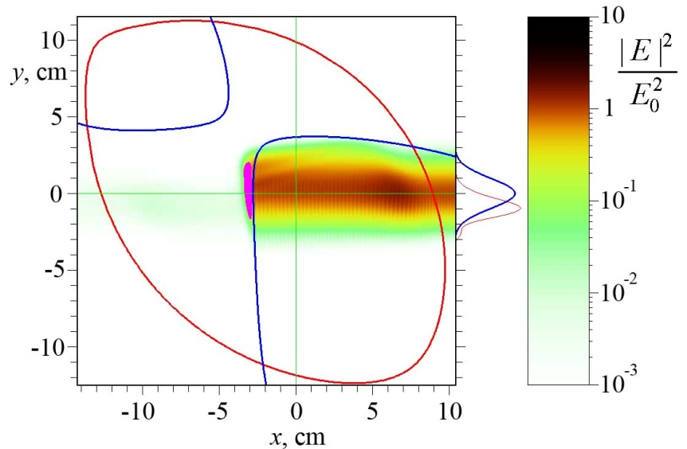
Fig. 1. Distribution of in the standard cross section of L-2M under ECR heating on the vacuum magnetic axis (x_{res} = −2.7 см). Heavy lines in the figure show the plasma boundary and the position of the resonance surface . The heavy line on the right of the figure shows the profile of the incident microwave power, while the light line shows the profile of the reflected microwave power on the 1000 : 1 scale relative to the incident power.

References
- Sakharov A.S. // J. Phys. Conf. Ser. 2018. V. 1094. P. 012011.
- Sakharov A S. // Plasma Phys. Rep. 2017. V. 43. P. 1065.
- Meshcheryakov A.I., Batanov G.M., Borzosekov V.D., et al. // J. Phys. Conf. Ser. 2017.
V. 907. P. 012016.
- Batanov G.M., Borzosekov V.D., Kolik L. V., et al. // Plasma Phys. Rep. 2013. V. 39. С. 882.

