STUDies OF THE effect OF EXTERNAL PERTURBATING ELECTRIC FIELDS ON Time EVOLUTION OF PLASMA IN THE T-10 TOKAMAK
Savrukhin P.V., Shestakov E.A., Khramenkov A.V.
NRC "Kurchatov institute", Moscow, Russia, psavrukhin@bk.ru
Effects of the external perturbed electric fields on plasma confinement and stability were studied in the T-10 tokamak. External electric fields were applied using a potential supply system to the electrode located inside the tokamak vacuum vessel (liner). The battery capacity C = 0.4 F, the maximum energy reserve W = 40.5 kJ, voltage 0–450 V. Supply of a positive potential relative to the liner boundary led to an increase in the density in the outer regions of the plasma discharge. The accumulation of impurities and a significant change in the electronic temperature were not observed. The threshold values of the potential leading to the density increase in the plasma regimes with tungsten limiters and in experiments with pre-conditioning of the first wall of the tokamak with lithium are determined. The supply of capacity, in some cases, led to the development of disruption instability. This effect may be associated with the destabilization of the MHD perturbations when the density limit is reached. The supply of potential at the initial stage of the discharge led to a strong increase in density during the entire pulse of the tokamak. The analysis showed that the effect on the plasma discharge can be associated with the initiation of arc discharges on the electrode surface when the potential is applied.
Analysis of the electrode surface showed the presence of deformations associated with arc discharges. Such arc discharges can be formed in high electric fields with the development of MHD perturbations and the supply of potential to the elements of the tokamak T-10. The formation of arc discharges is indirectly confirmed by comparing the parameters of electromagnetic disturbances observed in experiments on the T-10 tokamak with the characteristics of oscillations in the development of arc discharges at the laboratory bench.
Work is supported in part by Rosatom.
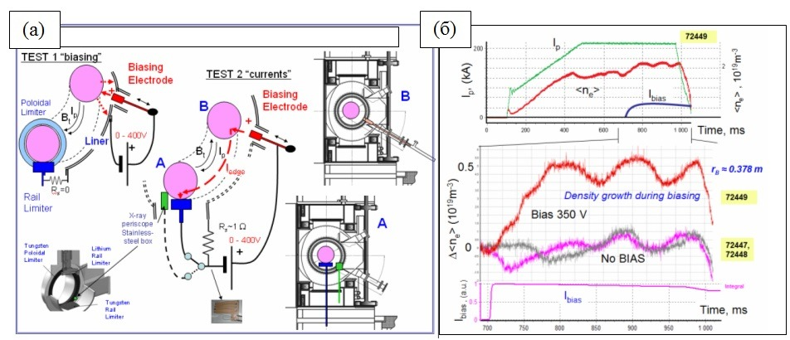
Fig. 1. (a) Scheme of experiments with supply of potential on tokamak T-10. (b) Evolution of the plasma parameters when applying a potential.

