studies OF THE Li-limiterS RADIATION IN VISIBLE AND INFRARED RANGES on the T-11M TOKAMAK
Dzhurik A.S., Lazarev V.B., Prishvicin A.S.
Troitsk Institute for Innovation and Fusion Research, Troitsk, Moscow, Russia, adzhurik@triniti.ru
The experiments with lithium limiters (LL) based on capillary-porous systems (CPS) are carried out on T-11M tokamak. Currently, for video recording interaction of plasma with lithium diaphragms used:
- two high-speed color cameras Baumer HXG20C operating in the visible range, with a maximum resolution of 2048 x 1024 pixels, with a shooting speed of 338 frames per second;
- two cameras Infratec VarioCam HD Head 680 and Infratec VarioCam HD Head 880, operating in the infrared range (7.5–14 µm), with a maximum resolution of 640 x 480 and 1024 x 768, respectively, with a shooting speed 60 frames per second.

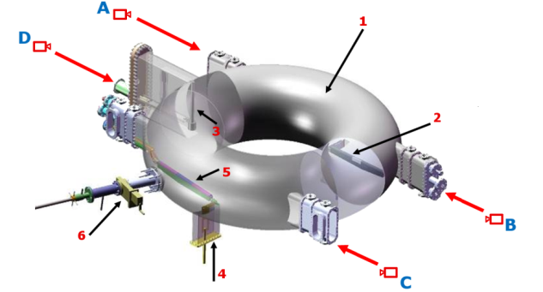
Fig 1. (1) vessel, (2) longitudial Li limiter, (3) vertical Li limiter, (4) C-limiter, (5) cryogenic target.
Video registration of two longitudinal tokamak T-11M limiters was carried out in the visible range from four different angles (Figure 1), with different speed, exposure, aperture, etc., and various light filters were used during the shooting: LiI (671 nm.), LiII (549 nm) and Hα (656 nm) [1]. To work with infrared video cameras on the tokamak T-11M installed two windows made of BaF2, transmitting the infrared radiation spectrum (angle B and D). The launch of all cameras is synchronized.
Cameras operating in the infrared range allowed to record the temperature distribution on the surface of lithium limiters during the discharge of the tokamak and to determine the thermal load on limiters surface. Simultaneous shooting of longitudinal limiters using cameras operating in the infrared and visible ranges allowed us to analyze the emission flux of neutral lithium depending from surface temperature and its distribution on the surface of the longitudinal limiters during all discharge.
References
- Dzhurik A.S., Scherbak A.N., Lazarev V.B., Belov A.M. Materials of the XVI All Russia Conference High Temperature Plasma Diagnostics. Zvenigorod, 2015.
- Dzhurik A.S., Lazarev V.B., Prishvicin A.S., Mahov N.S. Materials of the XLV Zvenigorod international conference on plasma physics and controlled fusion. Zvenigorod, 2018.

