Quasicontinuous spectra of tungsten in Fusion plasma: the Statistical model
¹Demura A.V., ¹Leontyev D.S., ^{1,2}Lisitsa V.S., ¹Shurygin V.A.
¹NRC “Kurchatov Institute”, Moscow, Russia, leontievdmitiy@gmail.com
²National Research Nuclear University MEPhI, Moscow, Russia
Plasma emission spectra in modern thermonuclear facilities with magnet confinement, containing construction elements from tungsten, is a complex structure including a large massive of spectral lines belonging to ions at different ionization stages resulting in quasicontinuum spectrum – “quasicontinuum”. Level-by-level calculations of intensity distribution in these spectra are very laborious since complex structure of multielectron tungsten ions resulting in the appearance of extremely large number of close radiative transitions [1].
In the present work, to describe the quasicontinuum spectra of tungsten in the thermonuclear plasma we use a statistical model of multielectron ion, which allows finding the averaged envelope of many lines in the given spectrum range. To calculate the quasi-continuum of the individual transitions i→j, the following general formula is used:
(1)
where N_{i} is the population of an exited level, ω is a transition frequency, A_{ij} is the Einstein radiative coefficient, f_{ij} is the oscillator strength.
The statistical approach, in which the oscillator strengths and energy are functional of an electron density distribution inside of an ion, significantly simplify the calculations of the spectral distribution of radiation losses of heavy multielectron ions of tungsten in the high temperature plasma. The simplest form of the electron density distribution is Slater approximation [2]:
(2)
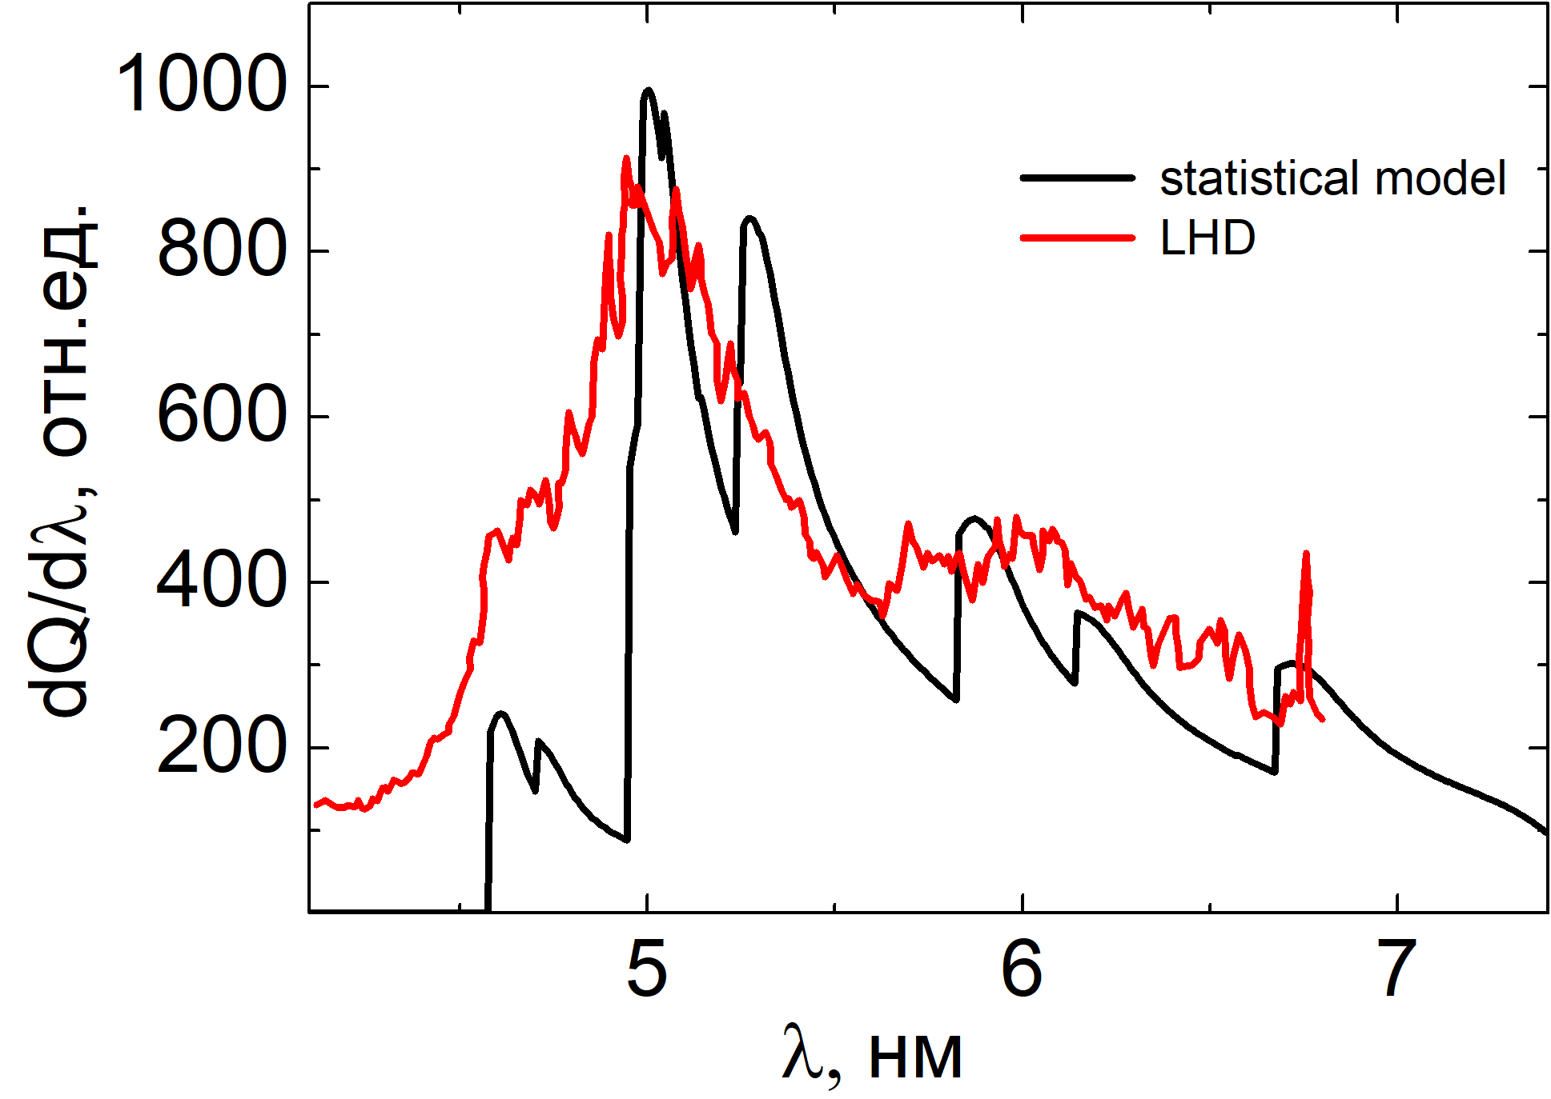
where A is the normalization constant of electrons number in the considered shell, and parameters κ and γ set the structure of a wave function determining the electron density distribution. γ is determinated as square root of a doubled ionization potential, and κ is matched such way based on experimental data to the maximum of the obtained function is consisted to the maximum peak of the a corresponding ion.
In the figure, there is the comparison of the experimental measurements from the stellarator LHD [1] with the theoretical computation result. The spectra of the radiative losses of tungsten at the temperature T = 3 keV is considered. As seen in the figure, the form of the theoretical curve repeats the experimental one.

References
- C. S. Harte, C. Suzuki, T. Kato et al., J. Phys. B: At. Mol. Opt. Phys. 43 (2010) 205004.
- Gott Yu., Particle Interaction with Matter (in Russian), Atomizdat, 1978.

