APPLICATION OF the MOROZOV–SOLOVYeV EQUATIONS FOR THE TOROIDAL MAGNETIC TRAP

Savelyev V.V.

Keldysh Institute of Applied Mathematics RAS, Russia, Moscow, [ssvvvv@rambler.ru](mailto:ssvvvv@rambler.ru)

In the well-known book “Questions of plasma theory” vol. 8, 1974. ed. by M.A. Leontovich, a large paper by A.I. Morozov and L.S. Solovyev “Steady-state flows of plasma in the magnetic field” was published. In Chapter 4 of this article, a general system of hydrodynamic equations for a two-component ideal plasma for the stationary case was written. For the case of axial symmetry, the authors were able to rewrite this system in a more observable form by introducing three flux functions (for magnetic field, for electrons and for ions). To close the problem it is required to define the integrals of energy (Bernoulli), the integrals of the angular momentums of plasma components and the entropy. In this paper, these equations will be used to study steady-state configurations of plasma in a toroidal magnetic trap.

The complete set of relations that make up the Morozov–Solovyov equations (MS equations) is given in [1, 2]. We consider the case of quasineutral plasma and consider the plasma at rest on average. The basic equations are written in terms of two functions - the magnetic flux function  and the full current function . They have the following form



Here is the energy integral (Bernoulli integral) of electrons (no dissipation),  is the integral angular momentum of electrons (axial symmetry), and  is the entropy of electrons. These three functions are constant along the electron current lines. As an example, we present the obtained in the calculations picture of the pressure level lines in the trap of circular cross-section for one of the variants

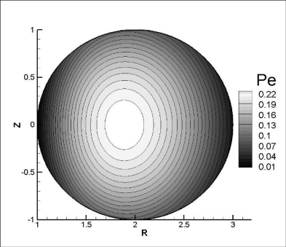

The study was supported by the Russian science Foundation (grant № 16-11-10278). The author is grateful to M.B. Gavrikov for useful discussions.

References

1. Morozov A.I., Soloviev L.S. Questions of plasma theory / ed. By M.A. Leontovich. Moscow: Gosatomizdat. 1974, issue 8, p. 3 [in Russian]
2. Morozov A.I. Introduction to plasmadynamics. Mocow: Fizmatlit. 2006 [in Russian].