model of electron heating in stationary plasma thruster
^{1,2}Podturova O.I., ^{1,2}Skovoroda A.A., ^{1,2}Sorokina E.A.
¹NRC “Kurchatov Institute”, olga_podturova@list.ru
²RUDN University
In this work a model of electron heating in stationary plasma thruster (SPT) [1] is developed. As it is known from the experiment, the geometry of magnetic field significantly affects the SPT operation. We calculate the three-dimensional magnetic and electric fields of a stationary plasma thruster, taking into account the influence of secondary plasma currents. In the obtained configuration the exact trajectories of the electron motion are calculated (see example in Fig. 1). The main source of electron heating in the developed model is a large electric field near the cathode. It is assumed that the cathode emits several amperes of unmagnetized electrons. It is shown that before being magnetized these electrons are able to obtain kinetic energy of several tens of eV, which is sufficient to provide a noticeable increase of plasma density to the cathode and establish the longitudinal potential distribution [2].
This work was supported by the Russian Science Foundation (Project №17-12-01470) and was partially carried out with the financial support of the Ministry of Education and Science of the Russian Federation (agreement 3.2223.2017 / 4.6).

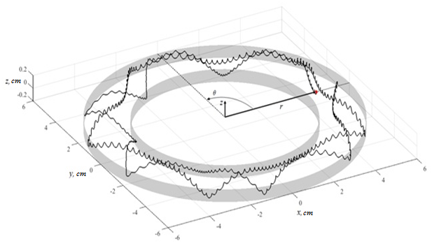
Figure 1. The trajectory of the electron, starting from the cathode with zero energy
References
- A.I. Morozov, Introduction to Plasma Dynamics (Fizmatlit, Moscow, 2006) [in Russian].
- Marini S., Pakter R. // Physics of Plasmas. 2017. V. 24. P. 053507.

