ESTIMATION OF COLD PLASMA JET CURRENT
¹Shershunova E.A., ²Puplauskis M., ¹Rebrov I.E.
¹Institute for Electrophysics and Electric Power, RAS, St. Petersburg, Russia,
eshershunova@gmail.com
²Bauman Moscow State Technical University, Moscow, Russia
Studies of plasma jet dynamics have shown that jet propagates in a similar way as a streamer at a speed of 10⁶-10⁸ cm/s, which is much bigger than the velocity of a pumped medium. There are some difficulties with the jet current measurements due to electromagnetic noise [1,2].
In this work, the plasma jet current measurements were carried by connecting it to an external metal collector. A plasma jet was formed in the air by pumping the discharge gap at a rate of 5 liters per minute. The discharge was realized in a quartz tube with an outer diameter of 5 mm and a thickness of 1 mm. A copper wire with a diameter of 2 mm, placed along the central axis of the tube, served as a high-voltage electrode. Copper foil glued to the tube was used as ground electrode. The jet was formed by applying nanosecond electrical pulses with an amplitude of 10 kV and a frequency of 3 kHz [3] to the high-voltage electrode. The current collector was made as a metal disk with an area of 1 cm² and placed perpendicular to the central tube axis 1 cm away from the tube end. The plasma jet current was eatimated through the voltage drop across the wave impedance of the coaxial cable (50 Ω) via the BNC connector. The coaxiality of the proposed design made it possible to measure currents of a milliampere magnitude with a sufficient precision.
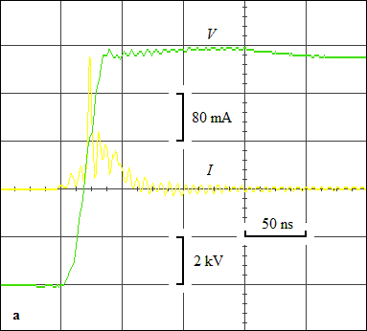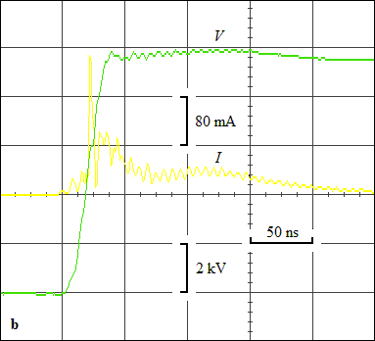
Figure 1. Waveforms of current I through the collector and voltage V on the high-voltage electrode: a - without air pumping, b - with pumping.
As can be seen from the waveforms in Fig. 1, when pumping, the second current peak with an amplitude of 50 mA appears, due to the conduction current of the plasma jet.
The work was carried out with the financial support of the RFBR, grant 16-08-01037A.
References
- Shao T., Yang W., Zhang C., Fang Z., Zhou Y., & Schamiloglu E., EPL (Europhysics letters), 2014, V. 107, №. 6, P. 6.
- Karakas E., Akman M. A., Laroussi M., Plasma Sources Science and Technology, 2012, V. 21, №. 3, P. 10.
- Malashin M. V., Moshkunov S. I., Khomich V. Y., Shershunova E. A., Instruments and Experimental Techniques, 2016, V. 59, №. 2, P. 226.

