OBSERVATIONS OF PLASMA LENS in DISCHARGE INITIATED BY ELECTRON BEAM
¹Drozdovsky A.A., ²Sasorov P.V., ¹Bogdanov A.V., ¹Drozdovsky S.A., ¹Gavrilin R.O., ¹Kantsyrev A.V., ¹Panyushkin V.A., ¹Roudskoy I.A., ¹Savin S.V., ³Karpov M.
¹NRC «Kurchatov Institute», Moscow, Russia, drozdovsky@mail.ru
²Keldysh Institute of Applied Mathematics, Moscow, Russia, Pavel.Sasorov@gmail.com
³Dukhov All-Russian Research Institute of Automatics, Moscow, Russia,
maksim.karpov@gmail.com
At the present time, active work is underway to create compact laser accelerators. In this case, it is important to solve the problems of the beams transportation by plasma lenses, in which the focusing magnetic field is created by a discharge current of the Z-pinch type [1]. For effective focusing it is necessary to investigate under what the breakdown initiation conditions uniform discharge current distribution is formed. In ITEP, the discharge initiated by an electron beam is studied. An experimental setup including an electron beam source with an energy of 250 keV and a current of up to 100 A is used [2]. The main method of observation of discharge plasma dynamics is registration of own plasma radiation in the visible and ultraviolet range. Studies have shown that the process of development of the discharge initiated by the electron beam is significantly different from the usual method of formation of Z pinch. In the specific case of a discharge in a tube with a radius of 2 cm with a current amplitude of 50 kA, the plasma distribution is uniform in a large time interval, about 0.5 µs, and captures the region of the maximum value of the discharge current. This is a necessary condition for creating a plasma lens with linear focusing forces. The following pictures shows how much different plasma density distribution for the discharge initiation by an electron beam (Fig. 1) from the usual discharge, well calculated in the MHD approximation
(Fig. 2).
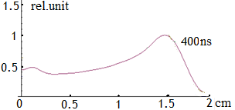 | 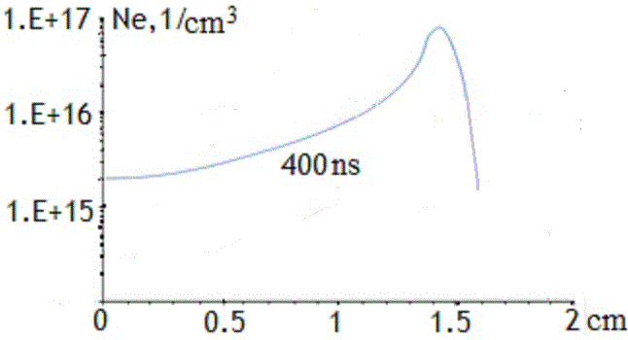
Fig. 1. Experimental electron density distribution. | Fig. 2. MHD electron density distribution.
References
- J. van Tilborg, E. Esarey, S.S. Bulanov, P.V. Sasorov, W.P. Leemans et al., Nonuniform discharge currents in active plasma lenses, PHYSICAL REVIEW ACCELERATORS AND BEAMS 20, 032803 (2017).
- A.A. Drozdovsky, A.V. Bogdanov, R.O. Gavrilin, S.A. Drozdovsky, A.V. Kantsyrev, I.V. Roudskoy, S.M. Savin, P.V. Sasorov, V.V. Yanenko. The Research of the Plasma of Z-Pinch Initiated by the Electron Beam. Physics of Particles and Nuclei Letters, 2018, Vol. 15, No. 7, © Pleiades Publishing, Ltd., 2018.

