Mathematical model of high-voltage glow discharge with hollow anode
Ulyanov K.N., Sapronova T.M.
VEI – the branch of FSUE "RFNC – VNIITF them. Academ.E.I. Zababakhin", Moscow, Russia, kulyanov@vei.ru
High-voltage glow discharge (HVGD) is a kind of anomalous glow discharge in the left branch of the Pashen curve at voltages of 5–150 kV. The discharge has a growing current-voltage characteristic. The current density at u ≈ 100 kV can reach a value of about 1 A/cm². Electrons come out from the cathode due to the potential pull-out by positive ions, as well as kinetic pull-out when the cathode is bombarded by ions and fast atoms. All the voltage is applied to the layer, so the electrons are accelerated in the layer and form an almost monoenergetic beam. The effective coefficient of secondary electron emission in the HVGD at U ≈ 30–150 kV can reach high values (10–20), so the electron accelerators, which use the VTR, have a high efficiency.
The kinetic theory of HVGD is developed in this work. The Poisson equation in the layer is solved taking into account the flow of ions coming from the plasma, gas ionization in the layer by electrons leaving the cathode surface, secondary electrons born in the layer, ions and fast atoms. The flow of fast atoms is formed in the layer by recharging the ions. Secondary electron emission by fast ions and atoms was taken into account. Different voltages, current densities, gas densities, coefficients of secondary electron emission and the geometric dimensions of the plasma the calculated values of the size of the layer, electric field distribution, flow density of ions and fast atoms. The current-voltage characteristics of the discharge are calculated. As an example, in the Figure, the current-voltage characteristics HVGD and given the size of the layer in helium for three values of the gas density.
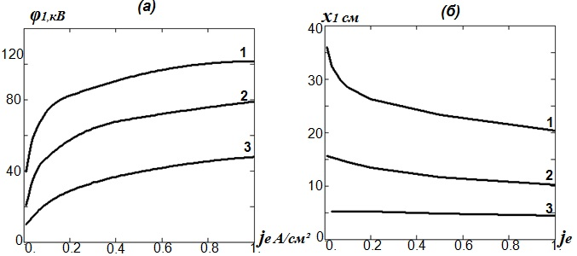
Figure. (a) current-voltage characteristics; (b) layer size for γ* = 15, L = 10 cm,
(1) N₀ = 0.5∙10¹⁵ cm^{–3}, (2) N₀ = 1∙10¹⁵ cm^{–3}, (3) N₀ = 2∙10¹⁵ cm^{–3}.
The developed mathematical model of HVGD is kinetic. The electrons leaving the cathode surface and the secondary electrons born in the layer move in escape mode. The free path of these electrons at high voltages is much larger than the size of the layer and plasma. The ratio of the flux density of secondary electrons to the current density of electrons leaving the cathode is small. So EEDF has a strongly expressed beam portion and a mild range of secondary electrons. It is this property that differs from the anomalous glow discharge, in which the electron spectrum covers the entire energy range without an explicit beam part.
References
- Ulyanov K.N. // TVT. 1978. Vol. 16. P. 1121.

