Modelling of the NBI contribution to the iter neutron energy spectra
¹Kormilitsyn T.M., ²Kashchuk Yu.A., ²Portnov D.V.
¹Moscow Institute of Physics and Technology (State University), Dolgoprudny, Russia
²Troitsk Institute for Innovative and Thermonuclear Investigations, Troitsk, Moscow, Russia
The study of fast ion behavior in reactor conditions is among the major goals of the ITER project. In this paper, the results of fast particle spectra caluclation for the ITER tangential spectrometer and vertical neutron camera are presented. The developed software allows for the simulation of particle spectra resulting from interaction of suprathermal ions with thermal background plasma. The method relies on direct reaction rate calculation and explicit fusion reaction kinematics modelling. Fast ion distribution function for the calculation was simulated by ASTRA Fokker–Plank solver 2D in velocity space [1].
The calculation was performed using the emulated ion redistribution, f_{fast}(r,v,μ) = f_{fast}(½ r_{max},v,μ), in the central zone r ∈ [0; ½ r_{max}]. S_{DTth} – neutron energy spectrum resulting from themal D and themal T ion interaction, S_{tot} total collimated neutron energy spectra, S_{DbTth}– neutron energy spectra resulting from beam D and themal T ion interaction. The “beam-thermal” neutron flux dominates at E > 16 MeV. Thus, in this range it looks possible to detect the ion redistribution resulting from plasma instabilities.
Note that for the beam-thermal spectra S_{DbTth} ~ P_{NBI}T_{e}^{3/2}n_{T}/n_{e} does not depend on the plasma density directly in contrast to the ‘thermal’ part, S_{DTth} ~ n². Thus, for low density phase of operation the accuracy of the ion temperature assessment could become worse (T_{iTNS} – core ion temperature assessed using energy range [14.5; 15] MeV, marked with green on figure 2).
The work is supported with the state contract of 19.04.2018 № Н.4а.241.19.18.1027 «Special equipment development, experimental manufacturing, testing and delivery preparation to meet Russian Federation’s liabilities on ITER project in 2018 year»
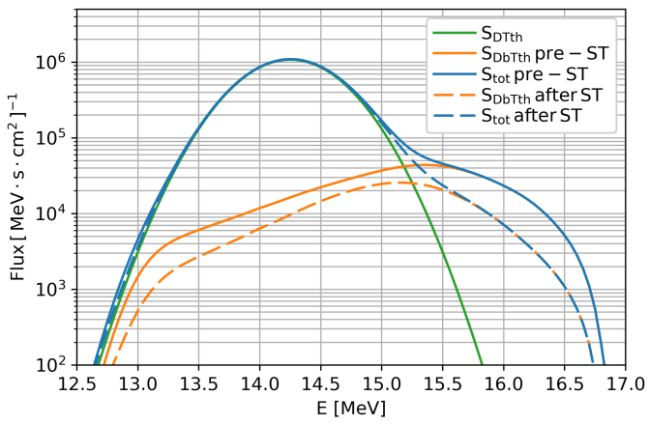  Figure 1. Simulated uncollided neutron spectra before and after the sawtooth event (pre-ST, after ST). | 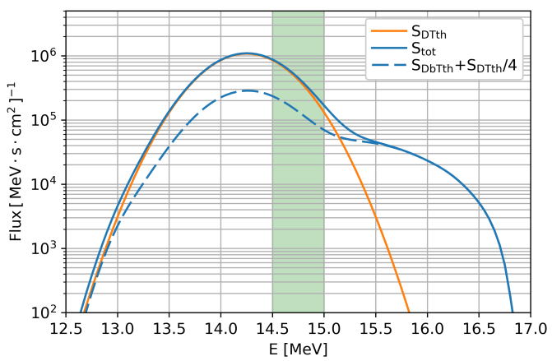  T_{1TNS} = 24.7 keV  T_{2TNS} = 30 keV  Figure 2. Impact of the S_{DbTth} spectra on the ion temperature assessment, T_{iTNS} = (dlnF/dE)⁻¹ю
References
- Polevoi A., Shirai H., Takizuka T. Benchmarking of the NBI block in ASTRA code versus the FMC calculations. - JAERI Data/Code 97-014, 1997.

