LIFE CYCLE OF A PART: FROM VIRTUAL TO REAL TOKAMAK
¹Alexandrov E.V., ¹Beteev S.G., ²Ivanov D.A., ¹Rakhmanov A.Yu., ^{1,2}Semashkin D.Yu., ¹Smirnov P.V.
¹Project center «ITER», Moscow, Russia, d.semashkin@iterrf.ru
²National research university MPEI, Moscow, Russia
The report describes in detail and describes the algorithm of virtual design of structural elements of the power system of ITER coils, describing the life cycle of the product (parts, assembly units) of the equipment of this system. A reactor of such dimensions cannot be built without the use of "model building tools". Production drawings made on the basis of the finally approved model, it is necessary to perform only knowing the exact location of the various systems surrounding this model (vacuum, cryo-, etc.); traces of cables and air ducts; location of cooling equipment; placement and layout inside the building. Modeling of all components and systems is carried out in the software package "CATIAv5" of the French company Dassault Systemes using module "Mechanical design", while strictly maintained a single design standard for all systems, components and parts.
For Fig. 1, the article presents an algorithm for forming the life cycle of a part from the conceptual model to the final production model and the subsequent release of working drawings, including the stages of creating preliminary, detailed and pre-production models.
The conceptual design stage is an important initial stage in the development of a virtual reactor. At this stage, the supplier and the customer jointly develop the General concept of this reactor system, work out the future design and location of the main units. At the conceptual design stage, a virtual lightweight model of the system is created, in which space is reserved in the total volume of the installation. In this case, the original reservation can be represented as a standard geometric shape-a cube, a parallelepiped, a cylinder, etc.
Virtual modeling allows you to reduce the time spent on development by instantaneous exchange of information flows, and quick tracking of the real state of the project. This reduces the cost of product development by reducing investment in the rework of the project due to the lack of defects and improves the quality of design, due to the existence of variant development of the project, the ability to work in more detail and deeply to work out any design solutions.

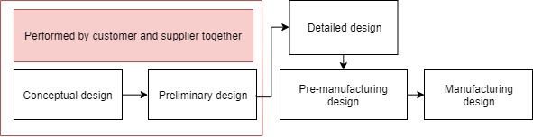

Fig. 1. Part life cycle.
References
- Mann. J., Werner W., CAD Manual 04-3 Mechanical Design Methodologies, guideline, 2014.

